|  |
| --- |
|  |
| COMPANY RATING WEBSITE  SCREEN DESIGN |

*Report #2*

|  |  |  |
| --- | --- | --- |
| **COMPANY RATING WEBSITE – *KẾ SINH NHAI TEAM*** | | |
| **Group Members** | Trần Quốc Hưng | SE02970 |
| Nguyễn Sơn Lâm | SE03090 |
| Nguyễn Việt Hùng | SE03293 |
| Nguyễn Nhật Quang | SE03122 |
| Trần Đăng | SE03039 |
| **Supervisor** | Bùi Đình Chiến | |
| **Project code** | CRW | |

**- Hanoi, 28/05/2016 -**

# SIGNATURE PAGE

AUTHOR: Trần Quốc Hưng 26/05/2016

Project manager

REVIEWERS: Nguyễn Nhật Quang 16/08/2016

Member

APPROVAL: Bùi Đình Chiến --/--/--16

Supervisor

Record of change

\*A - Added M - Modified D – Deleted

|  |  |  |  |  |  |
| --- | --- | --- | --- | --- | --- |
| Effective Date | Changed Item | A,M,D | Change Description | Reason for Change | Rev. Number |
| 26/05/2016 | Create Screen Design | **A** | First version | Create Screen Design | **1.0** |
| 16/08/2016 | Update Screen Design | **M** | First modification | Update Screen Design | **1.1** |
|  |  |  |  |  |  |
|  |  |  |  |  |  |

[SIGNATURE PAGE 2](#_Toc459390830)

[1. INTRODUCTION 4](#_Toc459390831)

[1.1. Purpose 4](#_Toc459390832)

[1.2. Definitions, Acronyms and Abbreviations 4](#_Toc459390833)

[1.3. Overview 4](#_Toc459390834)

[2. SCREEN FLOW 5](#_Toc459390835)

[3. SCREEN DESIGN 6](#_Toc459390836)

[3.1. Header 6](#_Toc459390837)

[3.2. Footer 8](#_Toc459390838)

[3.3. Homepage 8](#_Toc459390839)

[3.4. Register 9](#_Toc459390842)

[3.5. Login 11](#_Toc459390843)

[3.6. Forgot Password 13](#_Toc459390844)

[3.7. Account Management 14](#_Toc459390845)

[3.8. Notification 17](#_Toc459390846)

[3.9. Pending Reviews/Reports 19](#_Toc459390847)

[3.10. User Management 27](#_Toc459390848)

[3.11. Company Management 30](#_Toc459390849)

[3.12. Account Info 33](#_Toc459390850)

[3.13. Update Profile 37](#_Toc459390851)

[3.14. Change Avatar 38](#_Toc459390852)

[3.15. Change Password 40](#_Toc459390853)

[3.16. Review Management 41](#_Toc459390854)

[3.17. Follow List 43](#_Toc459390855)

[3.18. Bookmark List 45](#_Toc459390856)

[3.19. Company List 47](#_Toc459390857)

[3.20. Create Company 51](#_Toc459390858)

[3.21. Company Details 56](#_Toc459390859)

[3.22. Update Company 65](#_Toc459390860)

[3.23. Create Review 69](#_Toc459390861)

[3.24. Review Details 77](#_Toc459390862)

# INTRODUCTION

## Purpose

To ensure the consistency and simplicity in detailed design across all screens in theproduct interfaces, as well as across other products used by the same users.

Including definitions, acronyms, abbreviations, references and overview of CRW website.

## Definitions, Acronyms and Abbreviations

|  |  |  |
| --- | --- | --- |
| Abbreviations | Description | Comment |
| CRW | Company Rating Website |  |
| Q&A | Question and Answer |  |

1. Definitions, Acronyms and Abbreviations

## Overview

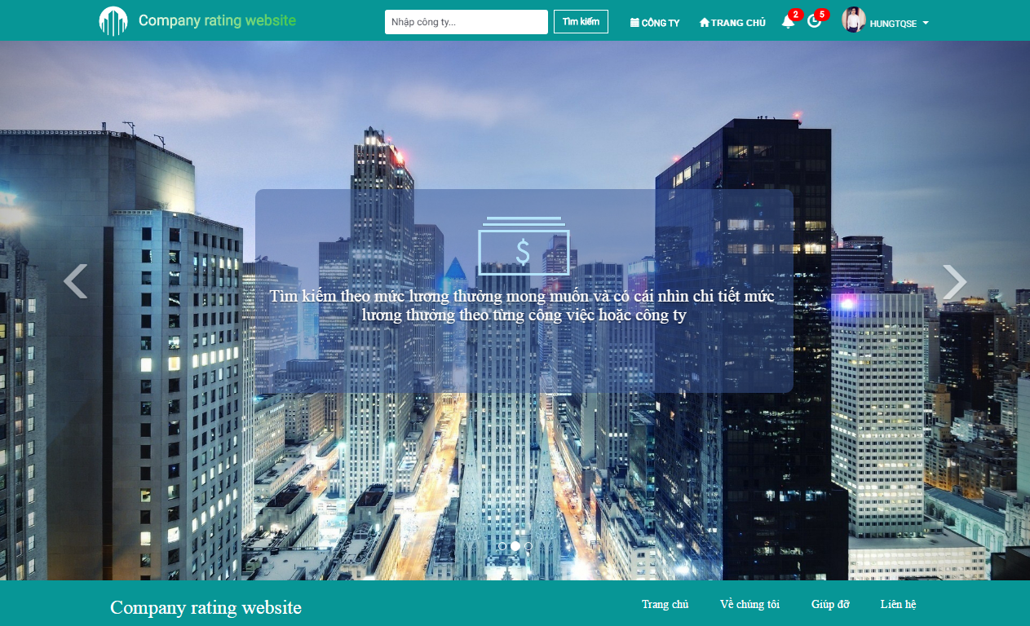

# SCREEN FLOW

E:\Work\Screen Flow.png

1. Client Screen Flow

# SCREEN DESIGN

## Header

E:\SHAREXXX\Screenshots\2016-08\opera_2016-08-19_02-37-26.png

1. Header

| No | Field name | Field name in Vietnamese | Type | Require | Mandatory | Max-Length | Description |
| --- | --- | --- | --- | --- | --- | --- | --- |
|  | CRW Logo | Lô gô CRW | Image |  |  |  | CRW’s logo |
|  | CRW Logo | Lô gô CRW | Hyperlink | Click |  |  | Go to CRW Hompage screen |
|  | Searchbar | Thanh tìm kiếm | Textbox | Input |  |  | Input keywords for searching companies |
|  | Search | Tìm kiếm | Button | Click |  |  | Search for matching companies with inputted keywords |
|  | Company | Công ty | Hyperlink | Click |  |  | Go to the Company List screen |
|  | Homepage | Trang chủ | Hyperlink | Click |  |  | Go to the CRW Homepage screen |
|  | Login | Đăng nhập | Hyperlink | Click |  |  | Go to the Login screen |
|  | Register | Đăng ký | Hyperlink | Click |  |  | Go to the Register screen |

1. Header

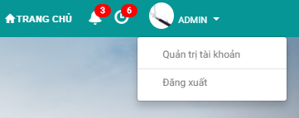

1. Header (Logged in)

| No | Field name | Field name in Vietnamese | Type | Require | Mandatory | Max-Length | Description |
| --- | --- | --- | --- | --- | --- | --- | --- |
|  | Notification | Thông báo | Hyperlink | Click |  |  | Go to the Notification List screen |
|  | Pending Reviews/Reports | Đánh giá/báo cáo đang chờ | Hyperlink | Click |  |  | Go to the Pending Review/Reports screen (Administrator) |
|  | Avatar | Ảnh đại diện | Image |  |  |  | Account’s avatar |
|  | Account Name | Tên tài khoản | Label |  |  |  | Account’s name |
|  | Account Name | Tên tài khoản | Dropdown Menu | Click |  |  | Opens the dropdown menu for other functions |
|  | Account Management | Quản lý tài khoản | Hyperlink | Click |  |  | Go to the Account Management screen |
|  | Logout | Đăng xuất | Hyperlink | Click |  |  | Logs the current account out |

1. Header (Logged in)

## Footer

E:\SHAREXXX\Screenshots\2016-08\opera_2016-08-19_02-39-06.png

1. Footer

| No | Field name | Field name in Vietnamese | Type | Require | Mandatory | Max-Length | Description |
| --- | --- | --- | --- | --- | --- | --- | --- |
|  | CRW Name | Tên trang web | Text |  |  |  | CRW’s name |
|  | Homepage | Trang chủ | Hyperlink | Click |  |  | Go to the CRW Homepage screen |
|  | About Us | Về chúng tôi | Hyperlink | Click |  |  | Open the About Us popup modal box |
|  | Contact | Liên hệ | Hyperlink | Click |  |  | Open the Contact popup modal box |

1. Footer

## Homepage

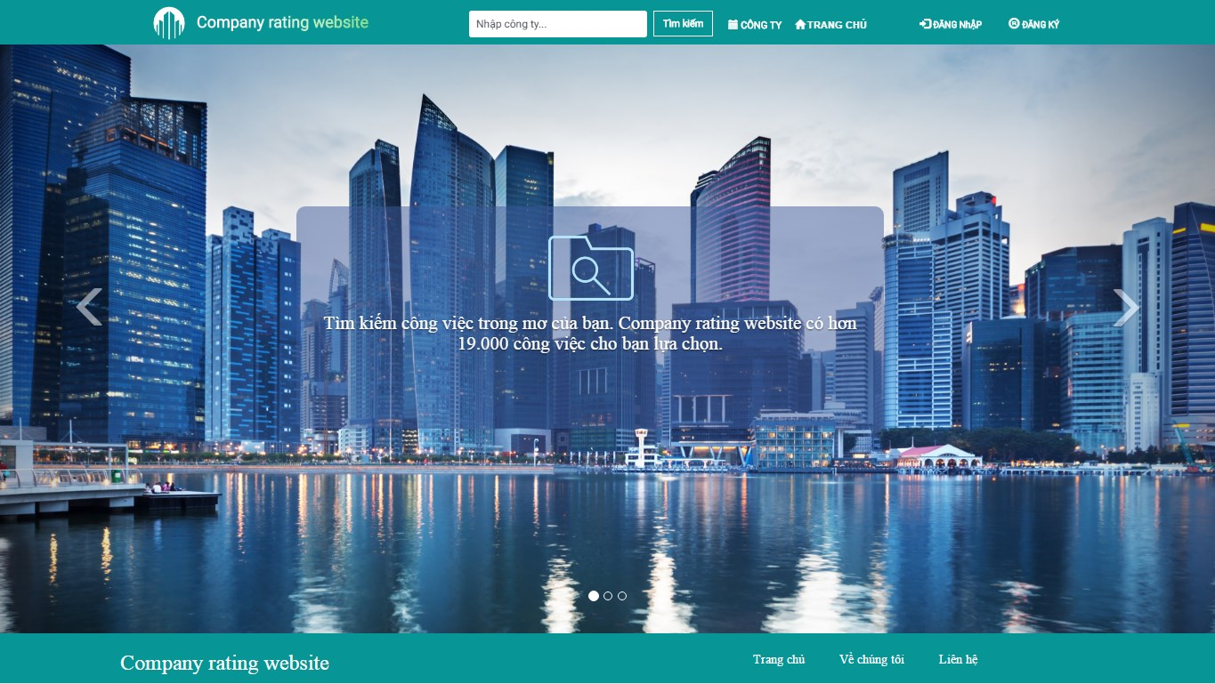

1. Homepage

| No | Field name | Field name in Vietnamese | Type | Require | Mandatory | Max-Length | Description |
| --- | --- | --- | --- | --- | --- | --- | --- |
|  | Homepage | Trang chủ | Carousel | Click |  |  | A carosel of background images and CRW’s statements |

1. Homepage

## Register

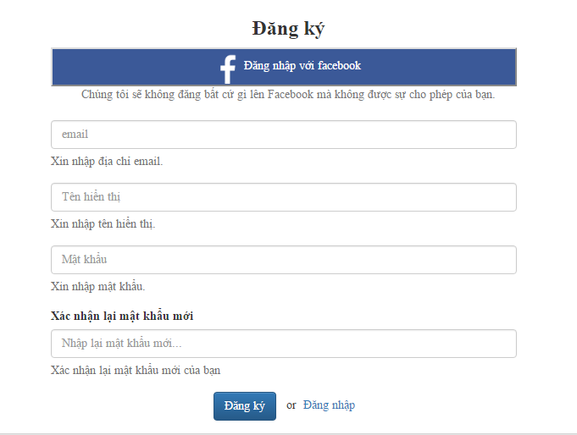

1. Register Form

| No | Field name | Field name in Vietnamese | Type | Require | Mandatory | Max-Length | Description |
| --- | --- | --- | --- | --- | --- | --- | --- |
|  | Register | Đăng ký | Label |  |  |  | Label for Register form |
|  | Login với Facebook | Đăng nhập với Facebook | Button | Click |  |  | Login with Facebook |
|  | Facebook Note | Lưu ý Facebook | Label |  |  |  | Label for note when registering with Facebook |
|  | Email | Email | Textbox | Type | Y |  | Input user’s email |
|  | Email | Email | Label |  |  |  | Label for Email when field is empty or does not meet requirement |
|  | Account Name | Tên tài khoản | Textbox | Type | Y |  | Input Account display name |
|  | Account Name | Tên tài khoản | Label |  |  |  | Label for Account Name when field is empty or does not meet requirement |
|  | Password | Mật khẩu | Textbox | Type | Y | 8-50 | Input Password |
|  | Password | Mật khẩu | Label |  |  |  | Label for Password when field is empty or does not meet requirement |
|  | Input Confirm Password | Nhập lại mật khẩu | Textbox | Type | Y | 8-50 | Input Confirm Password |
|  | Input Confirm Password | Nhập lại mật khẩu | Label |  |  |  | Label for Confirm Password when field is empty or does not meet requirement |
|  | Password Strength | Độ mạnh của mật khẩu | Progress Bar |  |  |  | Show the relative strength of the password |
|  | Register | Đăng ký | Button | Click |  |  | Confirm Account Registration |
|  | Login | Đăng nhập | Hyperlink | Click |  |  | Go to the Login screen |

1. Register Form

## Login

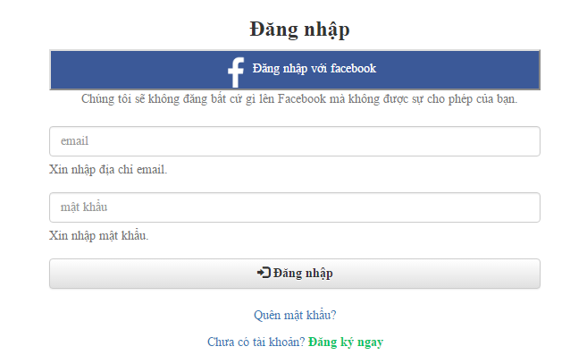

1. Login Form

| No | Field name | Field name in Vietnamese | Type | Require | Mandatory | Max-Length | Description |
| --- | --- | --- | --- | --- | --- | --- | --- |
|  | Login | Đăng nhập | Label |  |  |  | Label for Login form |
|  | Login with Facebook | Đăng nhập qua Facebook | Button | Click |  |  | Login with Facebook |
|  | Facebook Note | Lưu ý Facebook | Label |  |  |  | Label for note when registering with Facebook |
|  | Email | Email | Textbox | Type | Y |  | Input registered Email |
|  | Email | Email | Label |  |  |  | Label for Email when field is empty or does not meet requirement |
|  | Password | Mật khẩu | Textbox | Type | Y |  | Input registered Password |
|  | Password | Mật khẩu | Label |  |  |  | Label for Password when field is empty or does not meet requirement |
|  | Login | Đăng nhập | Button | Click |  |  | Confirm Login |
|  | Forgot Password | Quên mật khẩu | Hyperlink | Click |  |  | Go to the Forgot Password screen |
|  | Register Now | Đăng ký ngay | Hyperlink | Click |  |  | Go to the Register screen |

1. Login Screen

## E:\SHAREXXX\Screenshots\2016-08\opera_2016-08-19_02-25-48.pngForgot Password

1. Forgot Password Form

| No | Field name | Field name in Vietnamese | Type | Require | Mandatory | Max-Length | Description |
| --- | --- | --- | --- | --- | --- | --- | --- |
|  | Forgot Password | Quên mật khẩu | Label |  |  |  | Label for Forgot Password form |
|  | Email | Email | Textbox | Input | Y |  | Input account’s email for password restoration |
|  | Email | Email | Label |  |  |  | Label for Email when field is empty |
|  | Restore Password | Khôi phục mật khẩu | Button | Click |  |  | Request the system to restore the password via inputted email |
|  | Restore Password | Khôi phục mật khẩu | Label |  |  |  | Label for Restore Password when the email is either successfully sent or not |

1. Forgot Password Form

## Account Management

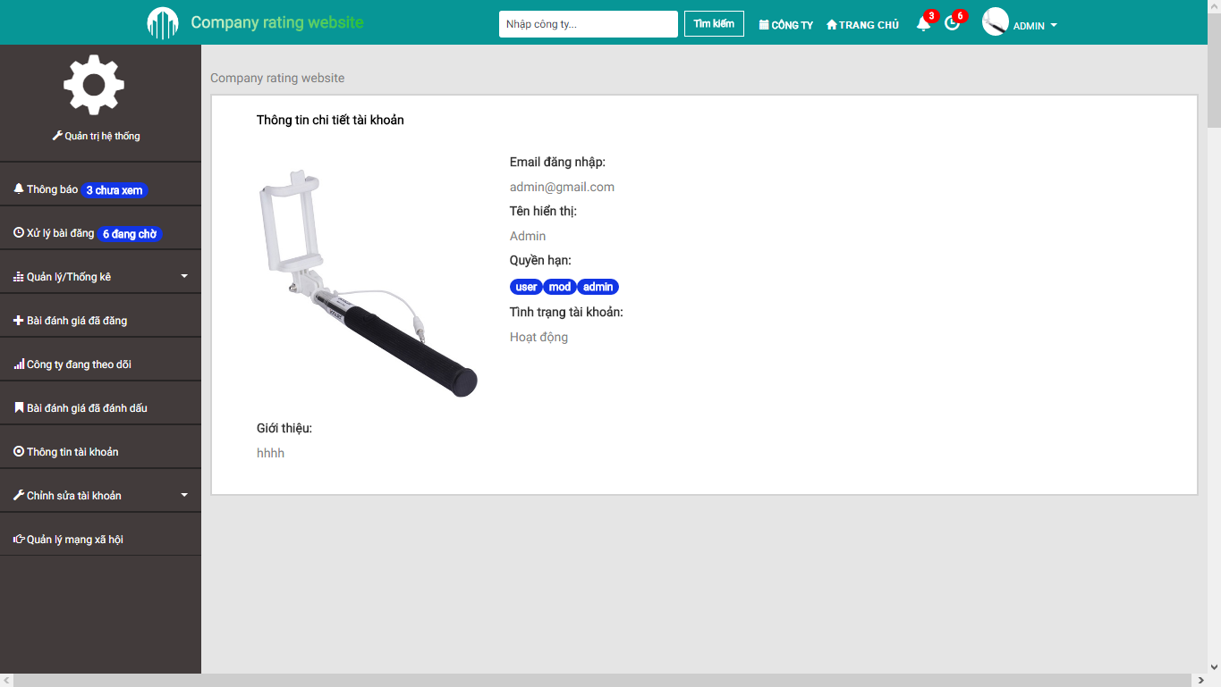

1. 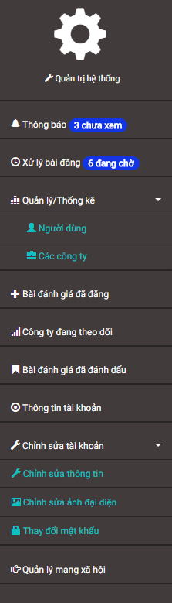Account Management
2. Account Management Menu

| No | Field name | Field name in Vietnamese | Type | Require | Mandatory | Max-Length | Description |
| --- | --- | --- | --- | --- | --- | --- | --- |
|  | Account Management Menu | Menu quản lý tài khoản | Sidebar |  |  |  | List of all available functions regarding management |
|  | Account Management | Quản lý tài khoản | Label |  |  |  | Label for Account Management menu |
|  | Notification | Thông báo | Hyperlink | Click |  |  | Go to the Notification List screen |
|  | Pending Reviews/Reports | Đánh giá/báo cáo đang chờ | Hyperlink | Click |  |  | Go to the Pending Review/Reports screen (Administrator) |
|  | Management And Statistics | Quản lý và thống kê | Dropdown Menu | Click |  |  | Opens the dropdown menu for other functions (Administrator) |
|  | User Management And Statistics | Quản lý và thống kê người dùng | Hyperlink | Click |  |  | Go to the User Management screen (Administrator) |
|  | Company Management And Statistics | Quản lý và thống kê công ty | Hyperlink | Click |  |  | Go to the Company Management screen (Administrator) |
|  | Submitted Reviews | Bài đánh giá đã đăng | Hyperlink | Click |  |  | Go to the Review List screen |
|  | Following Companies | Công ty đang theo dõi | Hyperlink | Click |  |  | Go to the Follow Company List screen |
|  | Bookmarked Reviews | Bài đánh giá đã đánh dấu | Hyperlink | Click |  |  | Go to the Bookmark List screen |
|  | Account Info | Thông tin tài khoản | Hyperlink | Click |  |  | Go to the Account Info screen |
|  | Edit Account | Chỉnh sửa tài khoản | Dropdown Menu | Click |  |  | Opens the dropdown menu for other functions |
|  | Edit Account Profile | Chỉnh sửa thông tin | Hyperlink | Click |  |  | Go to the Edit Profile screen |
|  | Change Account Avatar | Thay đổi ảnh đại diện | Hyperlink | Click |  |  | Go to the Change Avatar screen |
|  | Change Account Password | Thay đổi mật khẩu | Hyperlink | Click |  |  | Go to the Change Password screen |
|  | Social Network Management | Quản lý mạng xã hội | Hyperlink | Click |  |  | Go to the Social Account screen |

1. Account Management Menu

## Notification

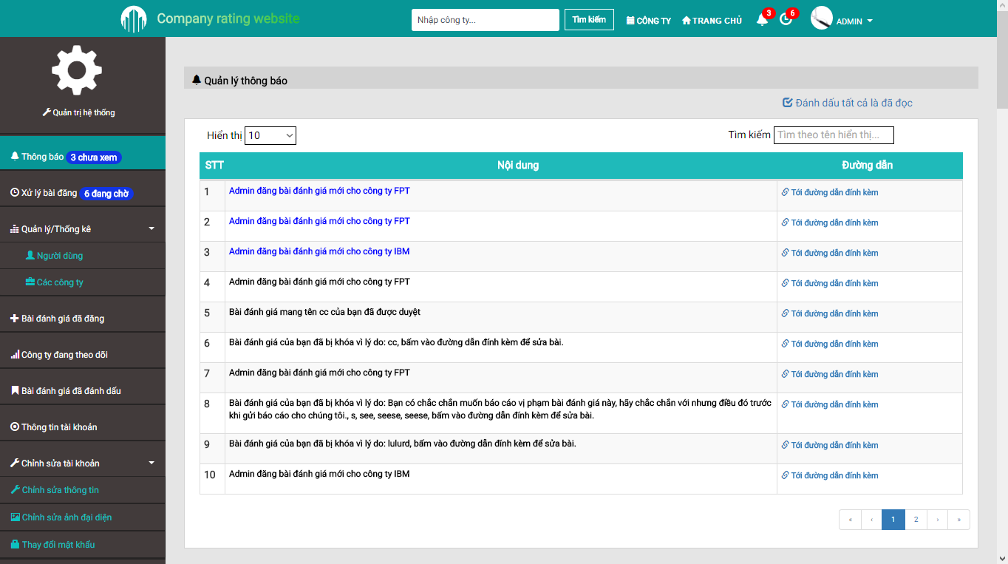

1. Notification Screen

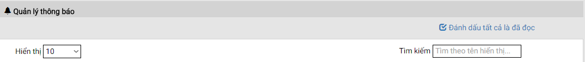

1. Search And Filter (Notification)

| No | Field name | Field name in Vietnamese | Type | Require | Mandatory | Max-Length | Description |
| --- | --- | --- | --- | --- | --- | --- | --- |
|  | Notification | Thông báo | Label |  |  |  | Label for Notification section |
|  | Mark All As Read | Đánh dấu tất cả đã đọc | Hyperlink | Click |  |  | Mark all notification as read |
|  | Display Limit | Giới hạn hiển thị | Select | Click |  |  | Limit the amount of notifications per single page |
|  | Filter | Bộ lọc | Textbox | Input |  |  | Filter the notifications accordingly to inputted keyword(s) |

1. Search And Filter (Notification)

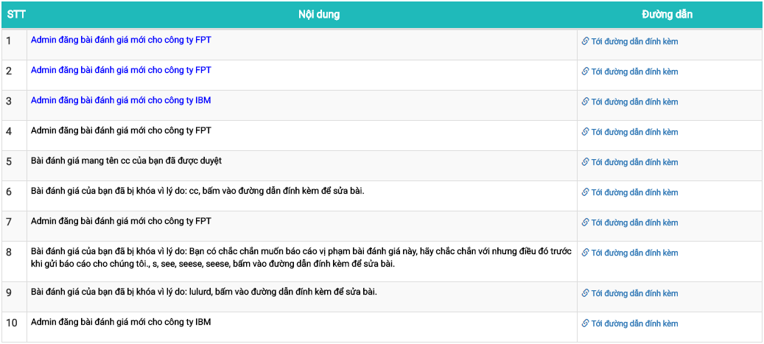

1. Notification Table

| No | Field name | Field name in Vietnamese | Type | Require | Mandatory | Max-Length | Description |
| --- | --- | --- | --- | --- | --- | --- | --- |
|  | Numbering | Số thứ tự | Label |  |  |  | Label for the numbering of a notification |
|  | Content | Nội dung | Text |  |  |  | The content of a notification  (Blue = Not Read, Black = Read) |
|  | Notification Link | Đường dẫn thông báo | Hyperlink | Click |  |  | Go to the notification’s triggering event |

1. Notification Table

## Pending Reviews/Reports

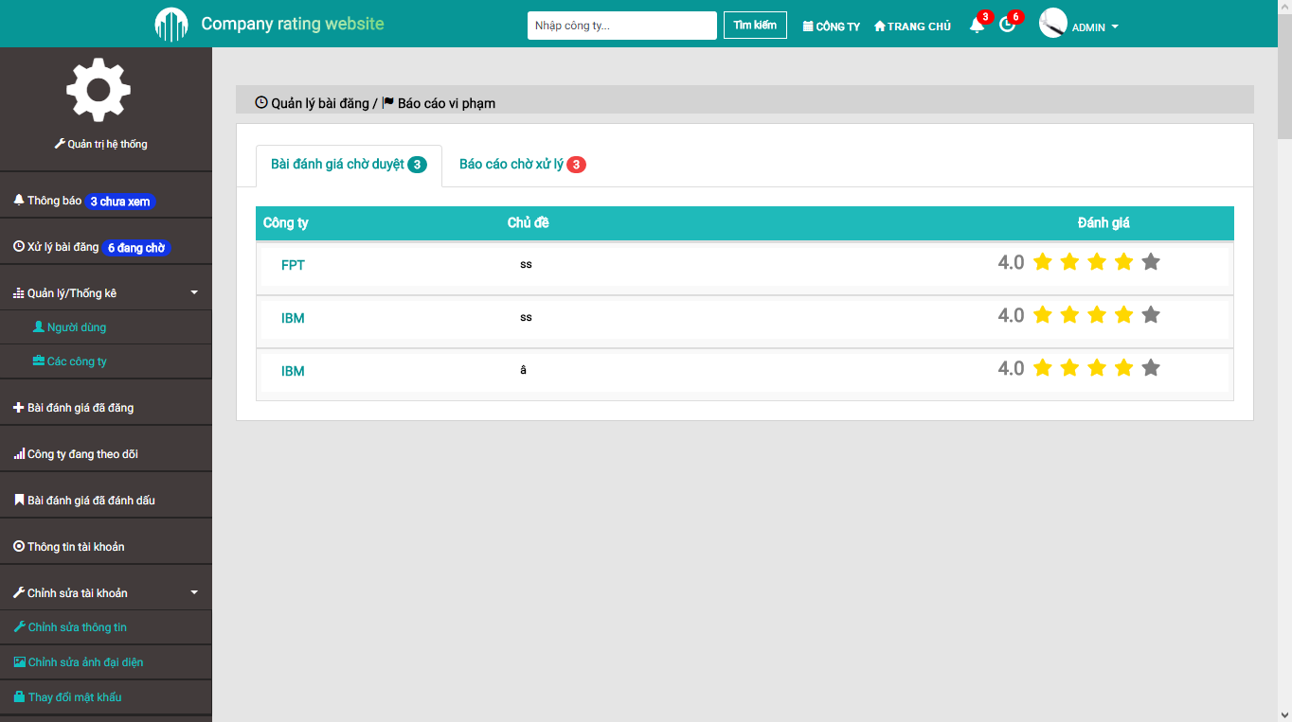

1. Pending Reviews/Reports Screen

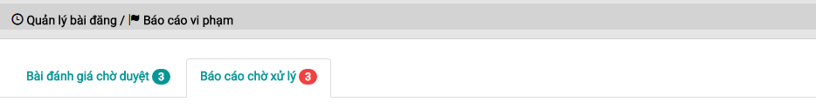 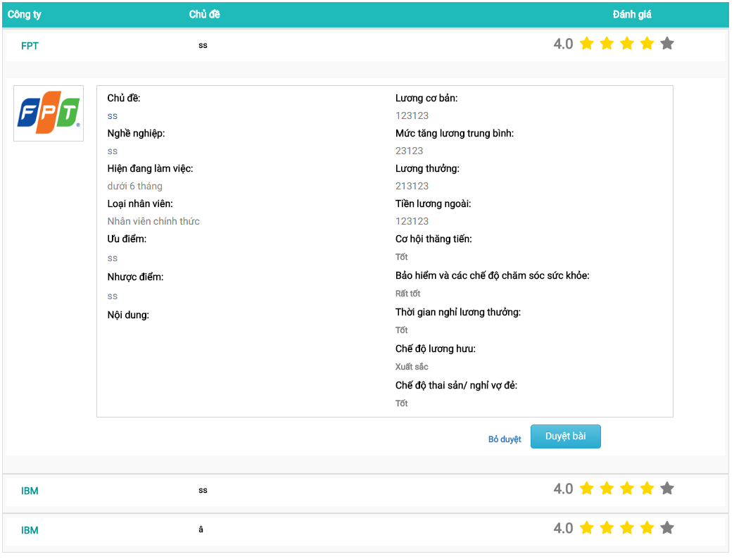

1. Pending Reviews

| No | Field name | Field name in Vietnamese | Type | Require | Mandatory | Max-Length | Description |
| --- | --- | --- | --- | --- | --- | --- | --- |
|  | Pending Reviews/Reports | Đánh giá/báo cáo đang chờ | Label |  |  |  | Label for Pending Reviews/Reports section |
|  | Pending Reviews | Đánh giá đang chờ | Tab | Click |  |  | Go to the Pending Reviews tab |
|  | Pending Reports | Báo cáo đang chờ | Tab | Click |  |  | Go to the Pending Reports tab |
|  | Company Name | Tên công ty | Label |  |  |  | Company’s name |
|  | Review Title | Tên bài đánh giá | Label |  |  |  | Review’s title |
|  | Review Rating | Điểm đánh giá | Label |  |  |  | Show the rating given by this review as number |
|  | Review Rating Star | Điểm đánh giá sao | Star Rating Bar |  |  |  | Show the rating given by this review as stars |
|  | Review | Bài đánh giá | Hyperlink | Click |  |  | Expand the chosen review to show its details |

1. Pending Reviews

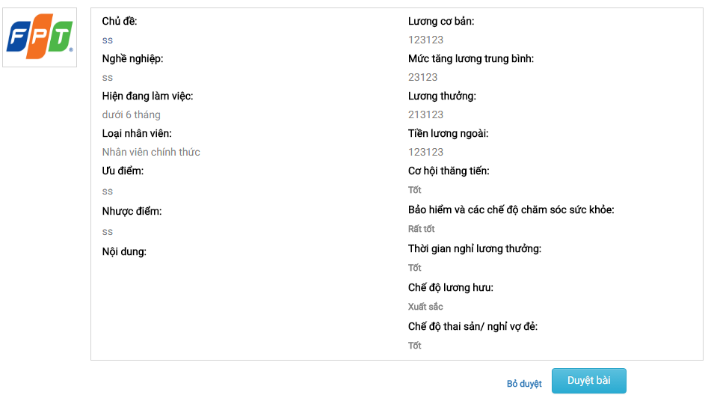

1. Pending Review Details

| No | Field name | Field name in Vietnamese | Type | Require | Mandatory | Max-Length | Description |
| --- | --- | --- | --- | --- | --- | --- | --- |
|  | Company Avatar | Ảnh đại diện công ty | Image |  |  |  | Company’s logo |
|  | Pending Review Details | Nội dung bài đánh giá đang chờ | Panel |  |  |  | Show the details of this pending review |
|  | Approve | Chấp nhận | Button | Click |  |  | Change the state of this pending review to Approved |
|  | Reject | Từ chối | Button | Click |  |  | Change the state of this pending review to Rejected |

1. Pending Reviews Details



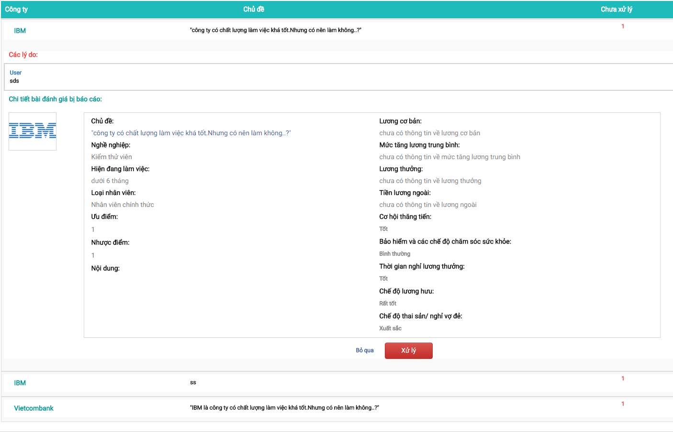

1. Pending Reports

| No | Field name | Field name in Vietnamese | Type | Require | Mandatory | Max-Length | Description |
| --- | --- | --- | --- | --- | --- | --- | --- |
|  | Pending Reviews/Reports | Đánh giá/báo cáo đang chờ | Label |  |  |  | Label for Pending Reviews/Reports section |
|  | Pending Reviews | Đánh giá đang chờ | Tab | Click |  |  | Go to the Pending Reviews tab |
|  | Pending Reports | Báo cáo đang chờ | Tab | Click |  |  | Go to the Pending Reports tab |
|  | Company Name | Tên công ty | Label |  |  |  | Company’s name |
|  | Review Title | Tên bài đánh giá | Label |  |  |  | Review’s title |
|  | Pending Reports | Báo cáo đang chờ | Label |  |  |  | Amount of pending reports for this review |
|  | Review | Bài đánh giá | Hyperlink | Click |  |  | Expand the chosen review to show its details |

1. Pending Reports

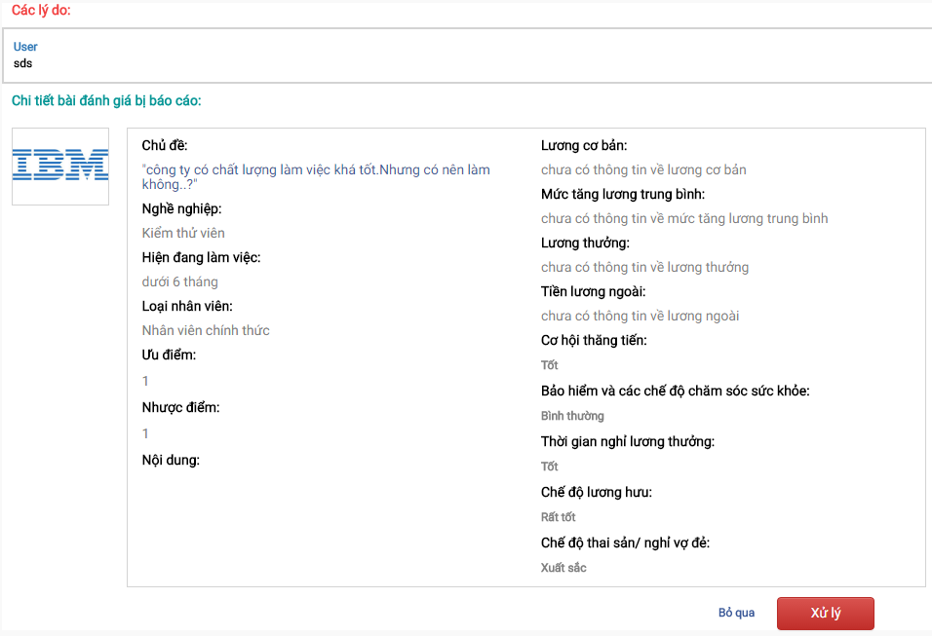

1. Reported Review Details

| No | Field name | Field name in Vietnamese | Type | Require | Mandatory | Max-Length | Description |
| --- | --- | --- | --- | --- | --- | --- | --- |
|  | Reasoning | Lý do | Label |  |  |  | Label for Reasoning section |
|  | Reporter Name | Tên người báo cáo | Label |  |  |  | Reporter’s name |
|  | Reporter Name | Tên người báo cáo | Hyperlink | Click |  |  | Go to the chosen user’s Account Info screen |
|  | Report Content | Nội dung báo cáo | Text |  |  |  | The content of a report regarding this review |
|  | Reported Review Details | Chi tiết bài bị báo cáo | Label |  |  |  | Label for Reported Review Details section |
|  | Company Avatar | Ảnh đại diện công ty | Image |  |  |  | Company’s logo |
|  | Reported Review Details | Nội dung bài đánh giá bị báo cáo | Panel |  |  |  | Show the details of this reported review |
|  | Approve | Chấp nhận | Button | Click |  |  | Approve the reports against this review and open the popup Reject Review modal box |
|  | Dismiss | Bỏ qua | Button | Click |  |  | Dismiss the reports against this review |

1. Reported Review Details

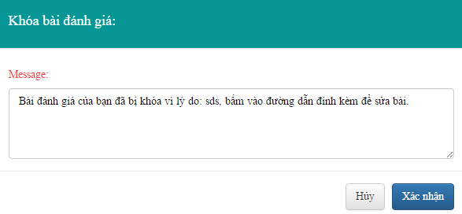

1. Reject Review Modal Box

| No | Field name | Field name in Vietnamese | Type | Require | Mandatory | Max-Length | Description |
| --- | --- | --- | --- | --- | --- | --- | --- |
|  | Reject Review | Khóa bài đánh giá | Label |  |  |  | Label for Reject Review modal box |
|  | Reject Reason | Lý do khóa bài | Textarea | Input |  |  | Input the reasoning for rejecting this review |
|  | Confirm | Xác nhận | Button | Click |  |  | Change the review state to Rejected and send a notification to the reviewer |
|  | Cancel | Hủy | Button | Click |  |  | Close the modal box |

1. Reject Review Modal Box

## User Management

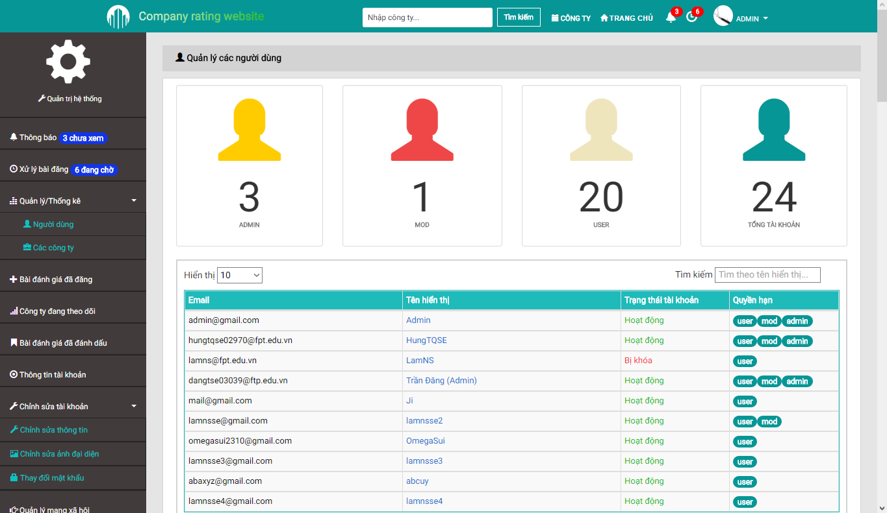

1. User Management Screen

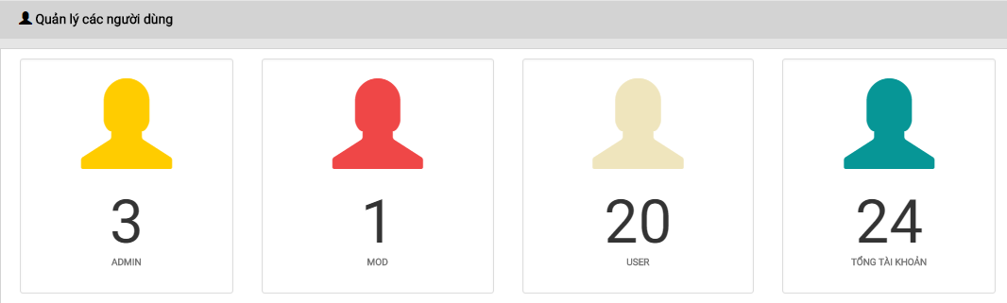

1. User Statistics

| No | Field name | Field name in Vietnamese | Type | Require | Mandatory | Max-Length | Description |
| --- | --- | --- | --- | --- | --- | --- | --- |
|  | User Management | Quản lý người dùng | Label |  |  |  | Label for User Management section |
|  | Administrator Statistics | Thống kê quản trị viên | Label |  |  |  | Show the amount of Administrators in the system |
|  | Moderator Statistics | Thống kê điều hành viên | Label |  |  |  | Show the amount of Moderators in the system |
|  | User Statistics | Thống kê thành viên | Label |  |  |  | Show the amount of Users in the system |
|  | Total Account | Tổng số tài khoản | Label |  |  |  | Show the amount of accounts in the system |

1. User Statistics

E:\SHAREXXX\Screenshots\2016-08\opera_2016-08-19_04-47-36.png

1. Search And Filter (User Management)

| No | Field name | Field name in Vietnamese | Type | Require | Mandatory | Max-Length | Description |
| --- | --- | --- | --- | --- | --- | --- | --- |
|  | Display Limit | Giới hạn hiển thị | Select | Click |  |  | Limit the amount of notifications per single page |
|  | Filter | Bộ lọc | Textbox | Input |  |  | Filter the notifications accordingly to inputted keyword(s) |

1. Search And Filter (User Management)

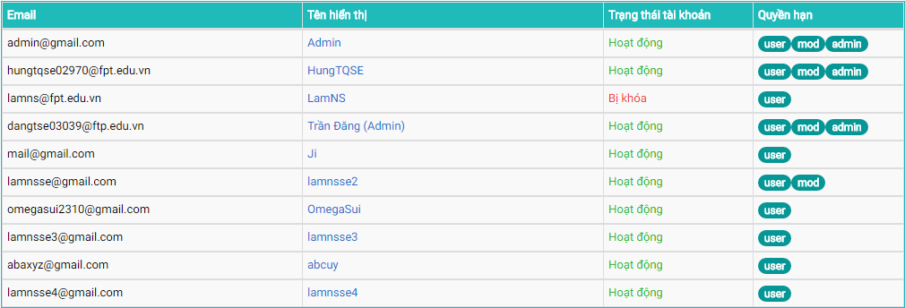

1. User Table

| No | Field name | Field name in Vietnamese | Type | Require | Mandatory | Max-Length | Description |
| --- | --- | --- | --- | --- | --- | --- | --- |
|  | Email | Email | Label |  |  |  | Account’s email |
|  | Display Name | Tên hiển thị | Hyperlink | Click |  |  | Go to chosen user’s Account Info screen |
|  | Display Name | Tên hiển thị | Label |  |  |  | Account’s display name |
|  | Account State | Trạng thái tài khoản | Label |  |  |  | Account’s state |
|  | Authority | Quyền hạn | Tag |  |  |  | Show account’s privilege |

1. User Table

## Company Management

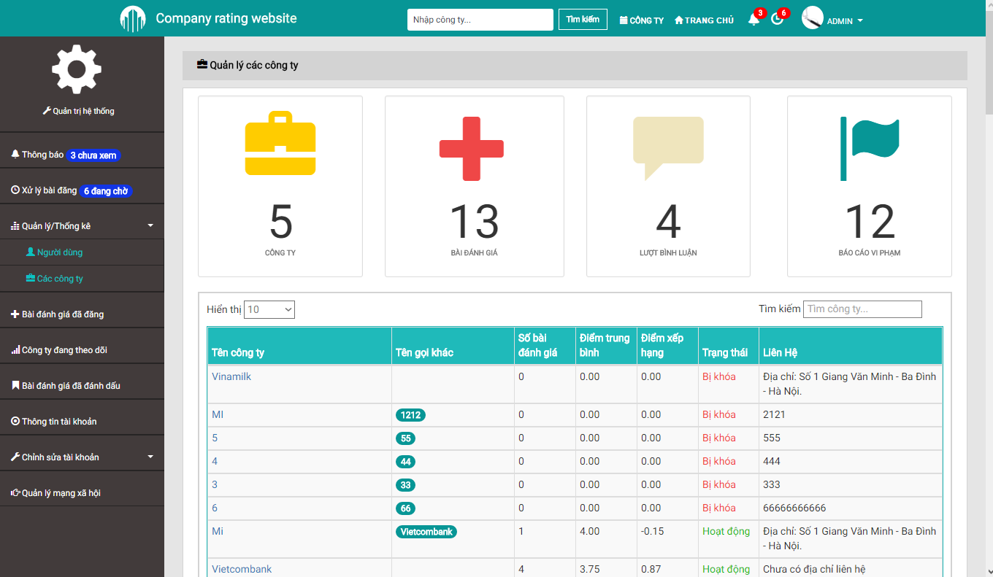

1. Company Management Screen

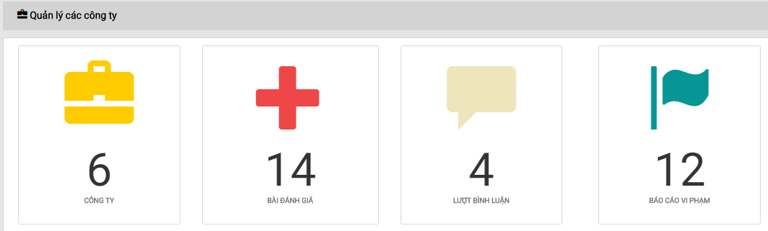

1. Company Statistics

| No | Field name | Field name in Vietnamese | Type | Require | Mandatory | Max-Length | Description |
| --- | --- | --- | --- | --- | --- | --- | --- |
|  | Company Management | Quản lý công ty | Label |  |  |  | Label for Company Management section |
|  | Company Statistics | Thống kê công ty | Label |  |  |  | Show the amount of companies in the system |
|  | Review Statistics | Thống kê đánh giá | Label |  |  |  | Show the amount of reviews in the system |
|  | Comment Statistics | Thống kê bình luận | Label |  |  |  | Show the amount of comments in the system |
|  | Report Statistics | Thống kê báo cáo | Label |  |  |  | Show the amount of reports in the system |

1. Company Statistics

E:\SHAREXXX\Screenshots\2016-08\opera_2016-08-19_04-47-36.png

1. Search And Filter (Company Management)

| No | Field name | Field name in Vietnamese | Type | Require | Mandatory | Max-Length | Description |
| --- | --- | --- | --- | --- | --- | --- | --- |
|  | Display Limit | Giới hạn hiển thị | Select | Click |  |  | Limit the amount of notifications per single page |
|  | Filter | Bộ lọc | Textbox | Input |  |  | Filter the notifications accordingly to inputted keyword(s) |

1. Search And Filter (Company Management)

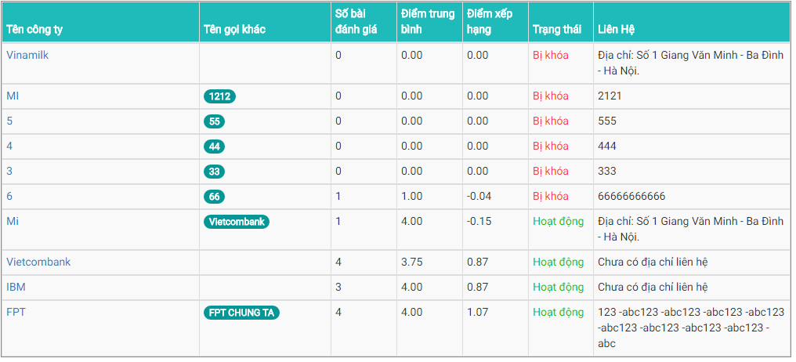

1. Company Table

| No | Field name | Field name in Vietnamese | Type | Require | Mandatory | Max-Length | Description |
| --- | --- | --- | --- | --- | --- | --- | --- |
|  | Company Name | Tên công ty | Hyperlink | Click |  |  | Go to the Detailed Company screen of chosen company |
|  | Company Name | Tên công ty | Label |  |  |  | Company’s name |
|  | Alias | Tên gọi khác | Tag |  |  |  | Company’s other name |
|  | Number of Reviews | Số bài đánh giá | Label |  |  |  | Show the amount of reviews this company has |
|  | Average Rating | Điểm trung bình | Label |  |  |  | Show the average rating for this company |
|  | Ranking Point | Điểm xếp hạng | Label |  |  |  | Show the ranking point for this company |
|  | Company State | Trạng thái | Label |  |  |  | Show the current state of this company |
|  | Company Contact | Liên hệ | Label |  |  |  | Company’s contact |

1. Company Table

## Account Info

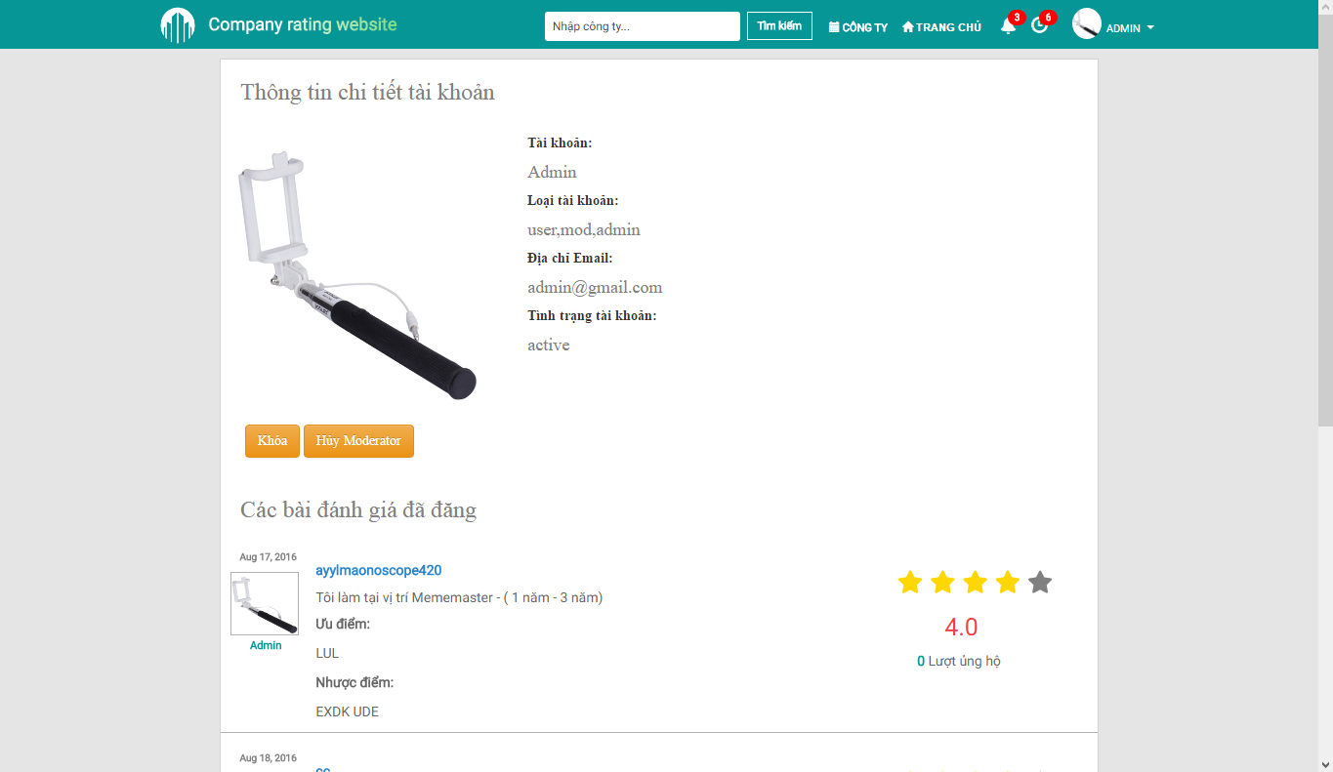

1. Account Info Screen

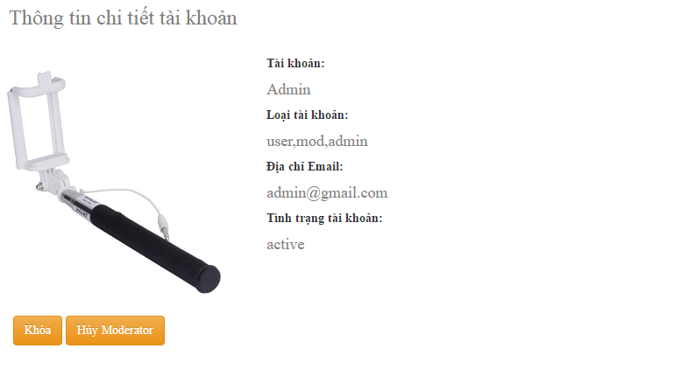E:\SHAREXXX\Screenshots\2016-08\opera_2016-08-19_05-03-30.png

1. Detailed Account Info

| No | Field name | Field name in Vietnamese | Type | Require | Mandatory | Max-Length | Description |
| --- | --- | --- | --- | --- | --- | --- | --- |
|  | Detailed Account Info | Thông tin chi tiết tài khoản | Label |  |  |  | Label for Detailed Account Info section |
|  | Account Details | Thông tin chi tiết | Panel |  |  |  | Show all info regarding this account |
|  | Lock | Khóa | Button | Click |  |  | Change the state of this account to Deactive (Administrator) |
|  | Unlock | Mở khóa | Button | Click |  |  | Change the state of this account to Active (Administrator) |
|  | Appoint Moderator | Bổ nhiệm điều hành viên | Button | Click |  |  | Assign the role of Moderator to this account (Administrator) |
|  | Demote Moderator | Cách chức điều hành viên | Button | Click |  |  | Remove the role of Moderator from this account (Administrator) |

1. Detailed Account Info

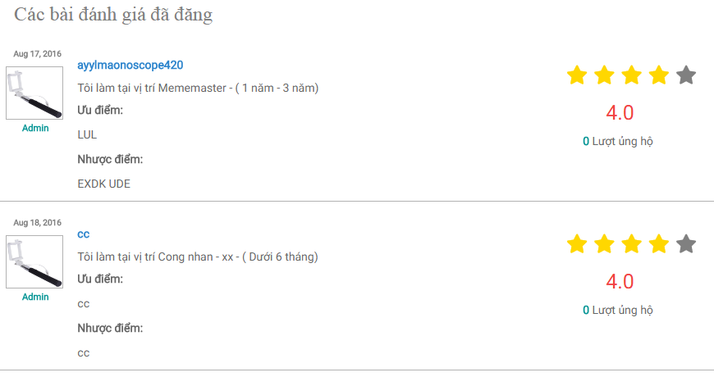

1. Posted Review

| No | Field name | Field name in Vietnamese | Type | Require | Mandatory | Max-Length | Description |
| --- | --- | --- | --- | --- | --- | --- | --- |
|  | Posted Review | Bài đánh giá đã đăng | Label |  |  |  | Label for Posted Review section |
|  | Reviewer Name | Tên người đánh giá | Label |  |  |  | Label for the reviewer’s name |
|  | Reviewer Avatar | Ảnh đại diện người đánh giá | Image |  |  |  | Reviewer’s avatar |
|  | Review Latest Date | Ngày cập nhật đánh giá lần cuối | Label |  |  |  | Label for the review’s latest updated date |
|  | Review Basic Content | Nội dung đánh giá căn bản | Panel Body |  |  |  | The basic content of the review |
|  | Review Star Rating | Điểm đánh giá sao | Star Rating Bar |  |  |  | Show the rating given by this review as stars |
|  | Review Rating | Điểm đánh giá | Label |  |  |  | Show the rating given by this review as number |
|  | Review Upvote | Số ủng hộ | Label |  |  |  | Label for the review’s upvote count |
|  | Review | Đánh giá | Hyperlink | Click |  |  | Go to the Detailed Review screen |

1. Posted Review

## Update Profile

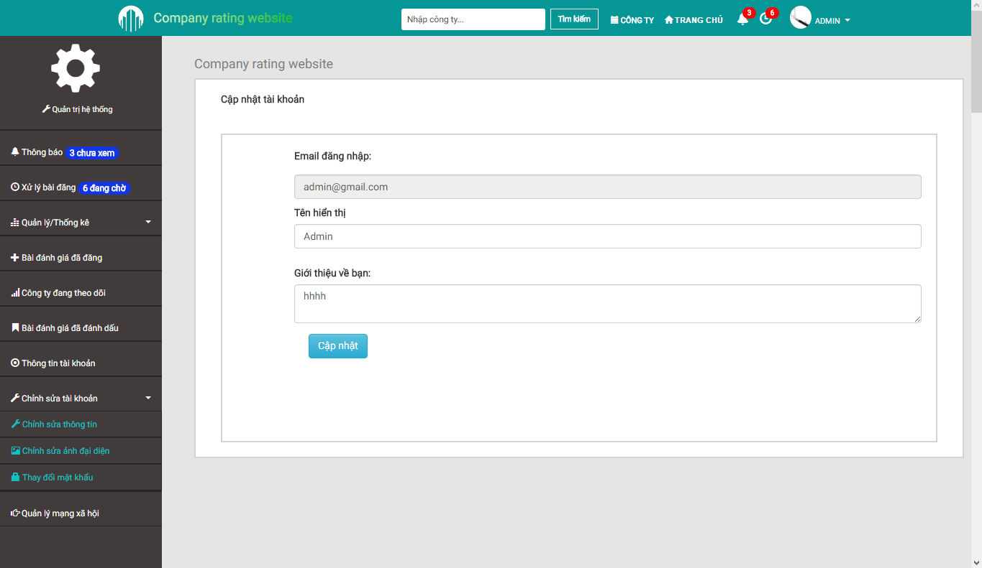

1. Update Profile Screen

| No | Field name | Field name in Vietnamese | Type | Require | Mandatory | Max-Length | Description |
| --- | --- | --- | --- | --- | --- | --- | --- |
|  | Update Profile | Cập nhật thông tin | Label |  |  |  | Label for Update Profile section |
|  | Registered Email | Email đăng ký | Textbox |  |  |  | Show this account’s registered email |
|  | Display Name | Tên hiển thị | Textbox | Input | Y |  | Input desired display name |
|  | Display Name | Tên hiển thị | Label |  |  |  | Label for Display Name field is empty or does not meet requirement |
|  | Profile | Thông tin bản thân | Textarea | Input |  |  | Input profile |
|  | Update | Cập nhật | Button | Click |  |  | Save the inputted changes |
|  | Update | Cập nhật | Label |  |  |  | Label for when Profile update is successful or not |

1. Update Profile

## Change Avatar

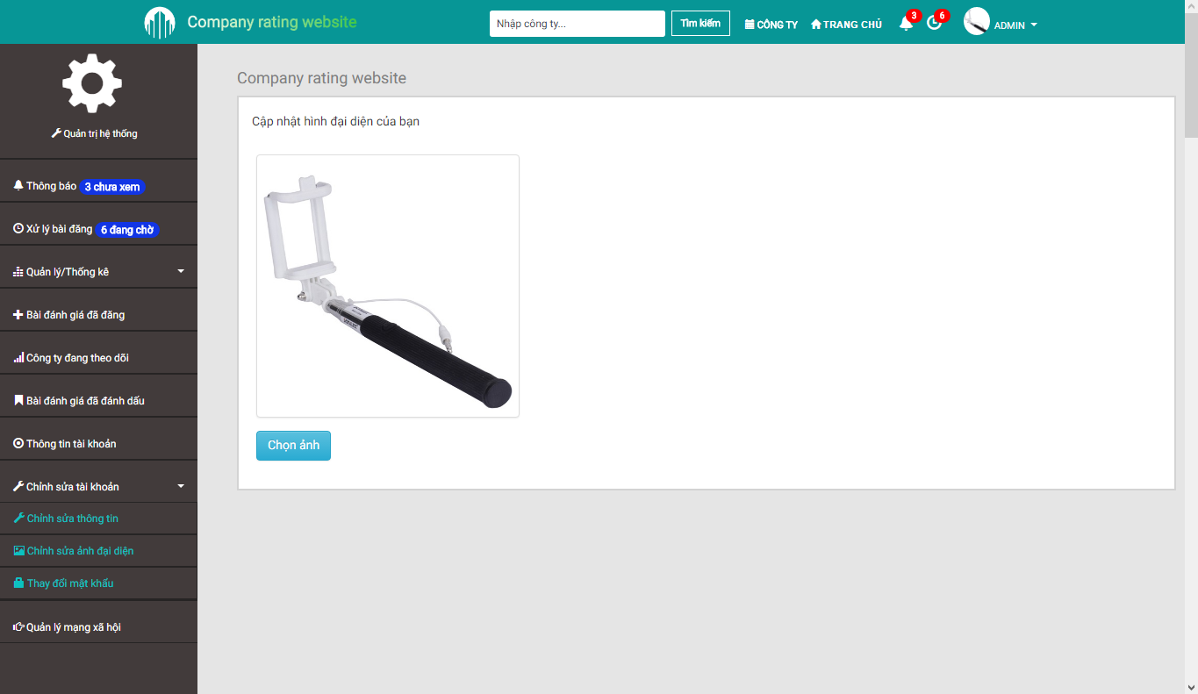

1. Change Avatar Screen

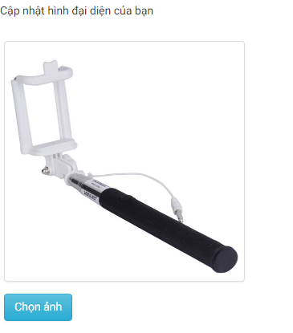 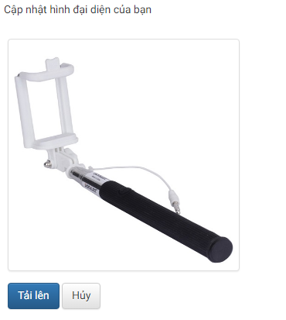

1. Change Avatar

| No | Field name | Field name in Vietnamese | Type | Require | Mandatory | Max-Length | Description |
| --- | --- | --- | --- | --- | --- | --- | --- |
|  | Change Avatar | Thay ảnh đại diện | Label |  |  |  | Label for Change Avatar section |
|  | Avatar | Ảnh đại diện | Image |  |  |  | Image previewer for current image or the newly uploaded one |
|  | Upload | Tải ảnh lên | Button | Click |  |  | Open the Explorer to choose an image as avatar |
|  | Confirm | Chấp nhận | Button | Click |  |  | Confirm the use of the currently shown image as avatar |
|  | Cancel | Hủy | Button | Click |  |  | Cancel avatar changes |

1. Change Avatar

## Change Password

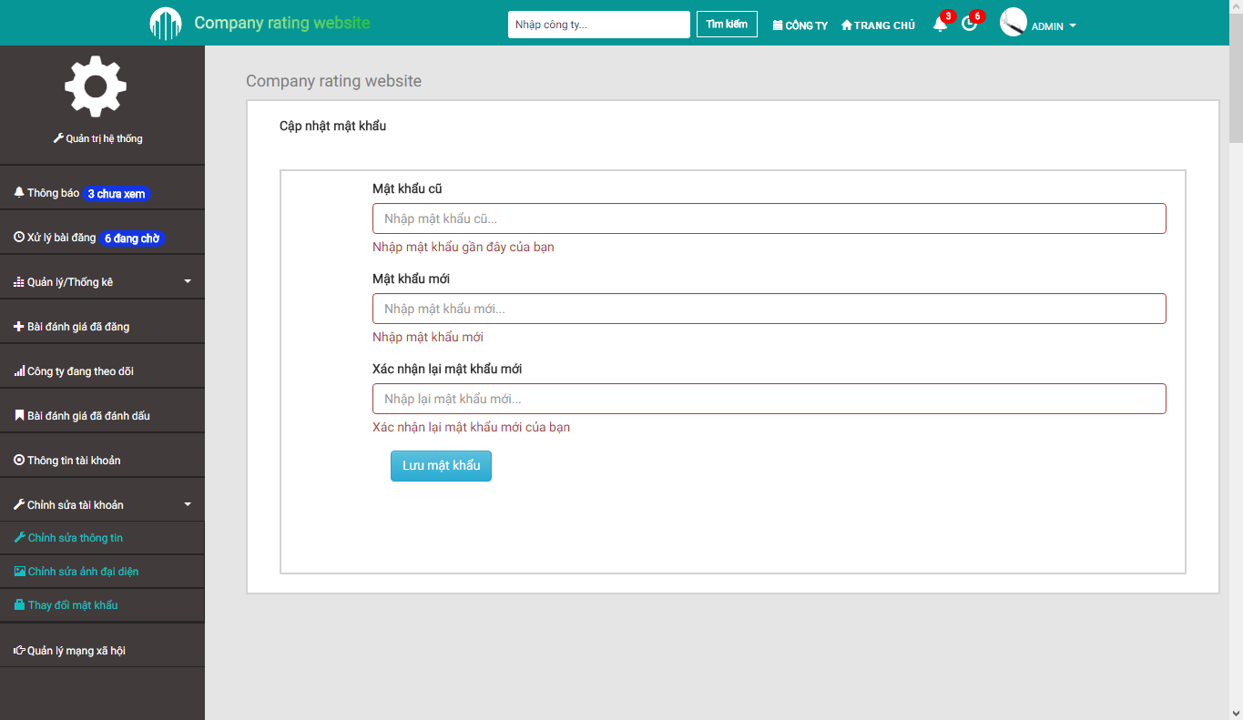

1. Change Password Screen

| No | Field name | Field name in Vietnamese | Type | Require | Mandatory | Max-Length | Description |
| --- | --- | --- | --- | --- | --- | --- | --- |
|  | Change Password | Thay đổi mật khẩu | Label |  |  |  | Label for Change Password section |
|  | Old Password | Mật khẩu cũ | Textbox | Input | Y |  | Input old password |
|  | Old Password | Mật khẩu cũ | Label |  |  |  | Label for Old Password field is empty or does not meet requirement |
|  | New Password | Mật khẩu mới | Textbox | Input | Y |  | Input new password |
|  | New Password | Mật khẩu mới | Label |  |  |  | Label for New Password field is empty or does not meet requirement |
|  | New Password Confirm | Xác nhận mật khẩu mới | Textbox | Input | Y |  | Input new password again |
|  | New Password Confirm | Xác nhận mật khẩu mới | Label |  |  |  | Label for New Password Confirm field is empty or does not meet requirement |
|  | Save New Password | Lưu mật khẩu | Button | Click |  |  | Save the inputted changes |

1. Change Password Screen

## Review Management

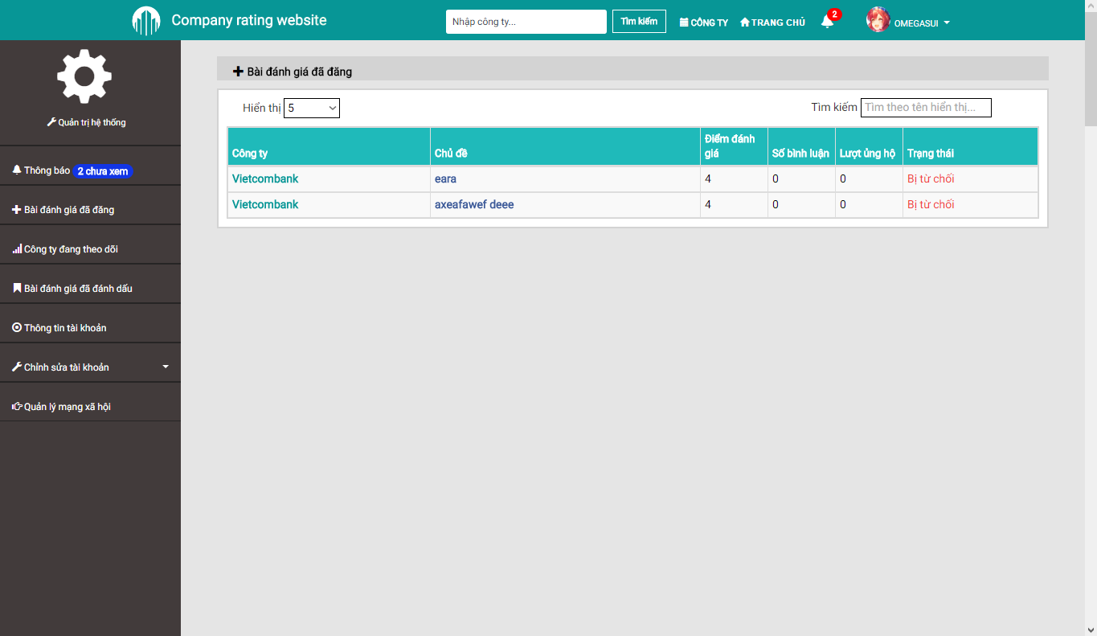

1. Review Management Screen



1. Search And Filter (Review Management)

| No | Field name | Field name in Vietnamese | Type | Require | Mandatory | Max-Length | Description |
| --- | --- | --- | --- | --- | --- | --- | --- |
|  | Review Management | Quản lý đánh giá | Label |  |  |  | Label for Review Management section |
|  | Display Limit | Giới hạn hiển thị | Select | Click |  |  | Limit the amount of notifications per single page |
|  | Filter | Bộ lọc | Textbox | Input |  |  | Filter the notifications accordingly to inputted keyword(s) |

1. Search And Filter (Review Management)

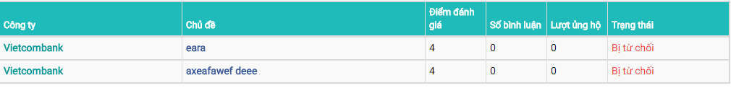

1. Review Table

| No | Field name | Field name in Vietnamese | Type | Require | Mandatory | Max-Length | Description |
| --- | --- | --- | --- | --- | --- | --- | --- |
|  | Company Name | Tên công ty | Label |  |  |  | Company’s name |
|  | Company Name | Tên công ty | Hyperlink | Click |  |  | Go to the chosen company’s Detailed Company screen |
|  | Review Title | Tiêu đề | Label |  |  |  | Review’s title |
|  | Review Title | Tiêu đề | Hyperlink | Click |  |  | Go to the chosen review’s Detailed Review screen |
|  | Rating | Điểm đánh giá | Label |  |  |  | Show the rating given by this review |
|  | Number of Comments | Số bình luận | Label |  |  |  | Show the amount of comments for this review |
|  | Number of Upvotes | Lượt ủng hộ | Label |  |  |  | Show the amount of upvotes for this review |
|  | Review State | Trạng thái | Label |  |  |  | Show the current state of this review |

1. Review Table

## Follow List

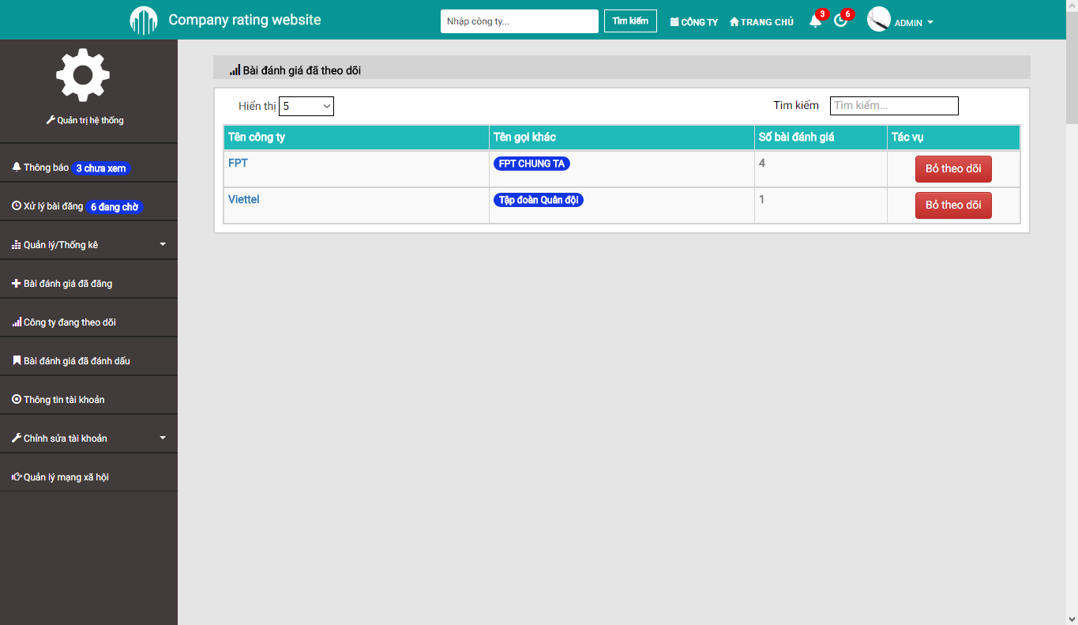

1. Follow List Screen



1. Search And Filter (Follow List)

| No | Field name | Field name in Vietnamese | Type | Require | Mandatory | Max-Length | Description |
| --- | --- | --- | --- | --- | --- | --- | --- |
|  | Follow | Theo dõi | Label |  |  |  | Label for Follow List section |
|  | Display Limit | Giới hạn hiển thị | Select | Click |  |  | Limit the amount of notifications per single page |
|  | Filter | Bộ lọc | Textbox | Input |  |  | Filter the notifications accordingly to inputted keyword(s) |

1. Search And Filter (Follow List)

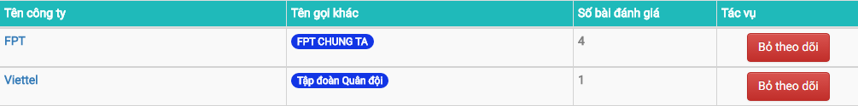

1. Followed Company Table

| No | Field name | Field name in Vietnamese | Type | Require | Mandatory | Max-Length | Description |
| --- | --- | --- | --- | --- | --- | --- | --- |
|  | Company Name | Tên công ty | Label |  |  |  | Company’s name |
|  | Company Name | Tên công ty | Hyperlink | Click |  |  | Go to the chosen company’s Detailed Company screen |
|  | Company Alias | Tên khác của công ty | Tag |  |  |  | Company’s other name |
|  | Number of Reviews | Số bài đánh giá | Label |  |  |  | Show the amount of reviews this company has |
|  | Unfollow | Bỏ theo dõi | Button | Click |  |  | Remove the chosen company from the follow list |

1. Followed Company Table

## Bookmark List

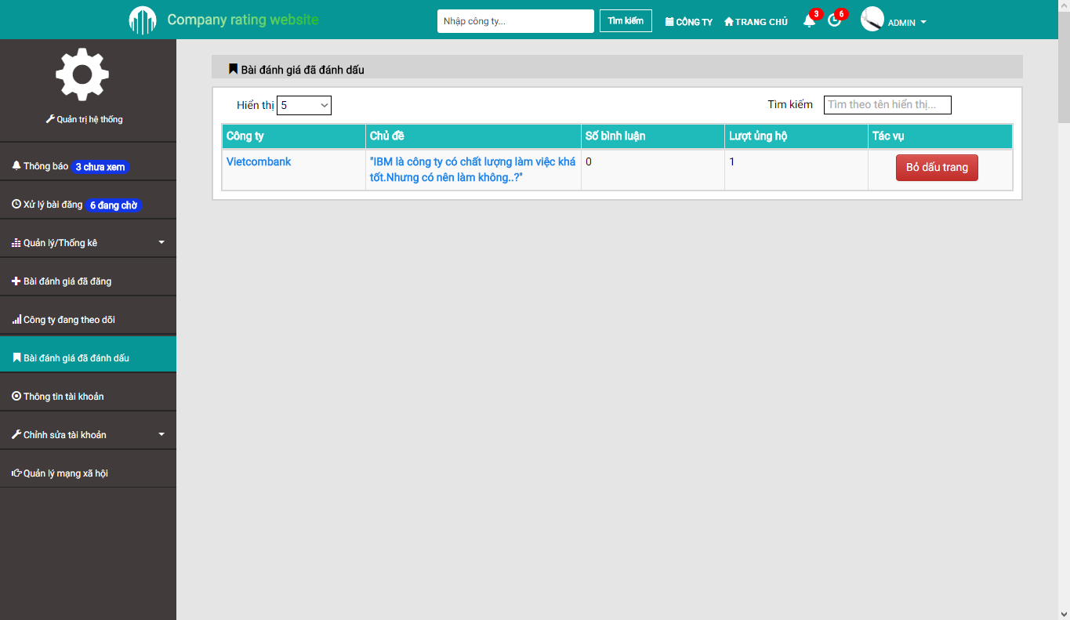

1. Bookmark List Screen



1. Search And Filter (Bookmark List)

| No | Field name | Field name in Vietnamese | Type | Require | Mandatory | Max-Length | Description |
| --- | --- | --- | --- | --- | --- | --- | --- |
|  | Bookmark | Dấu trang | Label |  |  |  | Label for Bookmark List section |
|  | Display Limit | Giới hạn hiển thị | Select | Click |  |  | Limit the amount of notifications per single page |
|  | Filter | Bộ lọc | Textbox | Input |  |  | Filter the notifications accordingly to inputted keyword(s) |

1. Search And Filter (Bookmark List)



1. Bookmark Table

| No | Field name | Field name in Vietnamese | Type | Require | Mandatory | Max-Length | Description |
| --- | --- | --- | --- | --- | --- | --- | --- |
|  | Company Name | Tên công ty | Label |  |  |  | Company’s name |
|  | Company Name | Tên công ty | Hyperlink | Click |  |  | Go to the chosen company’s Detailed Company screen |
|  | Review Title | Tiêu đề | Label |  |  |  | Review’s title |
|  | Review Title | Tiêu đề | Hyperlink | Click |  |  | Go to the chosen review’s Detailed Review screen |
|  | Number of Comments | Số bình luận | Label |  |  |  | Show the amount of comments for this review |
|  | Number of Upvotes | Lượt ủng hộ | Label |  |  |  | Show the amount of upvotes for this review |
|  | Remove Bookmark | Bỏ dấu trang | Button | Click |  |  | Remove the chosen review from the Bookmark list |

## Company List

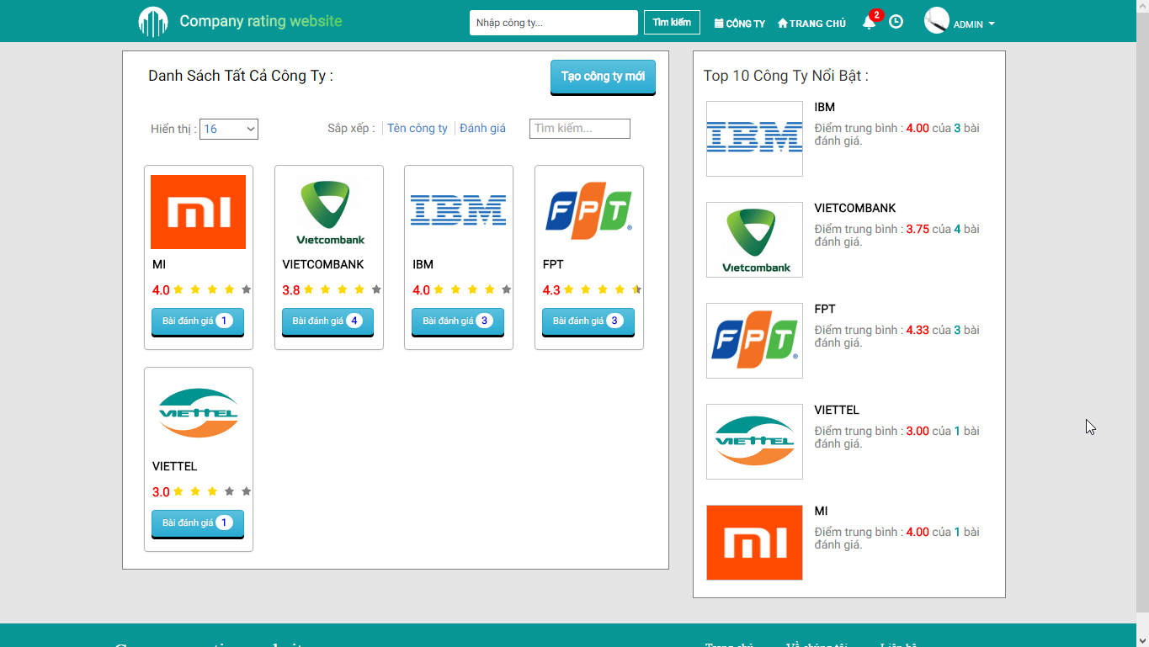

1. Company List Screen

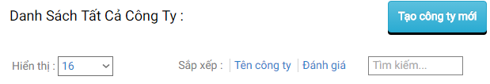

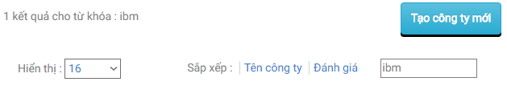

1. Search And Filter (Company List)

| No | Field name | Field name in Vietnamese | Type | Require | Mandatory | Max-Length | Description |
| --- | --- | --- | --- | --- | --- | --- | --- |
|  | Company List | Danh sách công ty | Label |  |  |  | Label for Company List section |
|  | Searchbar | Nhập công ty | Textbox |  |  |  | Input keywords for querying purposes |
|  | Search | Tìm kiếm | Button | Click |  |  | Input Search |
|  | Search Result | Kết quả tìm kiếm | Label |  |  |  | Label for amount of matching results with the given keywords |
|  | Create New Company | Tạo mới công ty | Button | Click |  |  | Go to the Create Company screen |
|  | Sort by Name | Xếp theo tên công ty | Hyperlink | Click |  |  | Sort by Company’s name alphabetically |
|  | Sort by Reviews | Xếp theo số đánh giá | Hyperlink | Click |  |  | Sort by Company’s amount of reviews numberically |

1. Search And Filter (Company List)

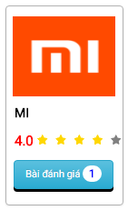

1. Company Thumbnail

| No | Field name | Field name in Vietnamese | Type | Require | Mandatory | Max-Length | Description |
| --- | --- | --- | --- | --- | --- | --- | --- |
|  | Company Avatar | Ảnh đại diện công ty | Image |  |  |  | Company’s logo |
|  | Company Name | Tên công ty | Label |  |  |  | Company’s name |
|  | Average Rating | Điểm đánh giá trung bình | Label |  |  |  | Show average ratings of this company as number |
|  | Average Star Rating | Điểm đánh giá trung bình | Star Rating Bar |  |  |  | Show average ratings of this company as stars |
|  | Number of Reviews | Số bài đánh giá | Label |  |  |  | Show the amount of reviews for this company |
|  | Company Thumbnail | Công ty | Hyperlink | Click |  |  | Go to the Detailed Company screen of this company |

1. 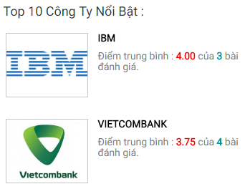Company Thumbnail
2. Top 10 Companies

| No | Field name | Field name in Vietnamese | Type | Require | Mandatory | Max-Length | Description |
| --- | --- | --- | --- | --- | --- | --- | --- |
|  | Top 10 | Tốp 10 | Label |  |  |  | Label for Top 10 Companies section |
|  | Company Avatar | Ảnh đại diện công ty | Image |  |  |  | Company’s logo |
|  | Company Name | Tên công ty | Label |  |  |  | Company’s name |
|  | Average Rating | Điểm đánh giá trung bình | Label |  |  |  | Label for Average Rating and amount of reviews |
|  | Average Star Rating | Điểm đánh giá trung bình | Star Rating Bar |  |  |  | Show average ratings of this company as stars |
|  | Company Thumbnail | Công ty | Hyperlink | Click |  |  | Go to the Detailed Company screen of this company |

1. Top 10 Companies

## Create Company

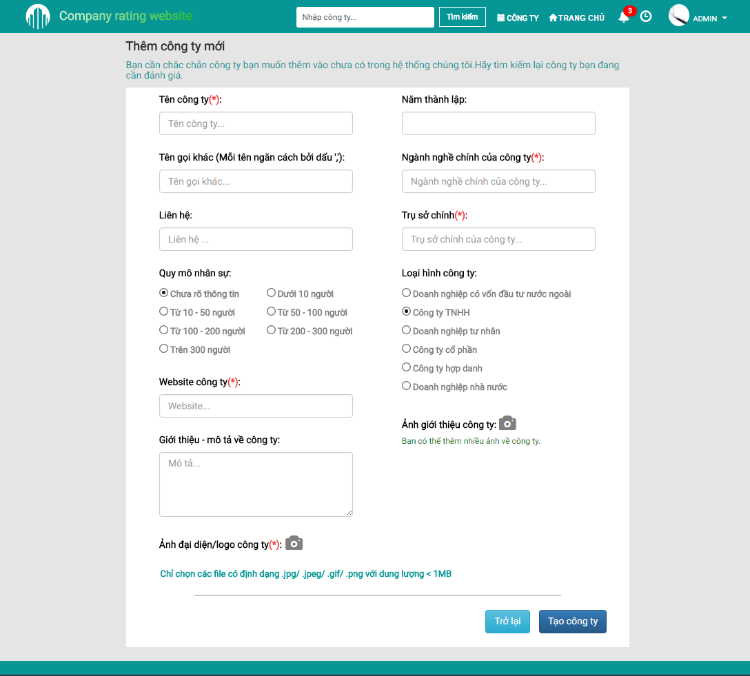

1. Create Company Screen

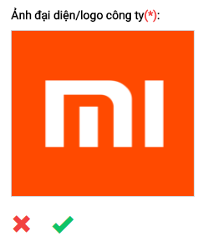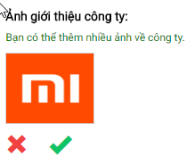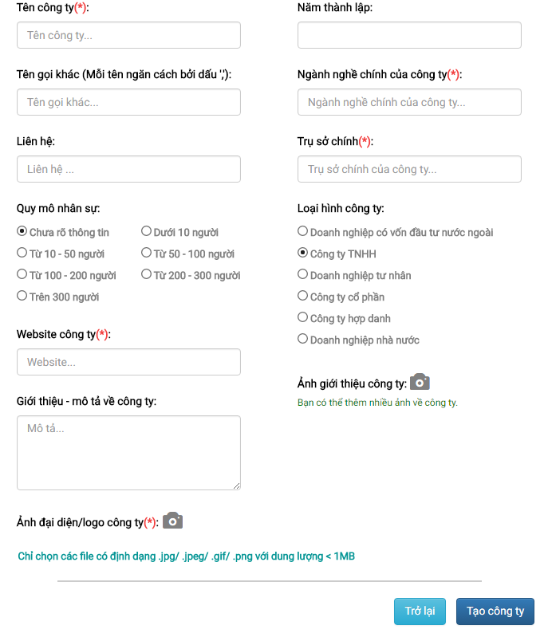

1. Create Company Form

| No | Field name | Field name in Vietnamese | Type | Require | Mandatory | Max-Length | Description |
| --- | --- | --- | --- | --- | --- | --- | --- |
|  | Create Company | Thêm công ty | Label |  |  |  | Label for Create Company form |
|  | Company Status | Trạng thái công ty | Radio Button | Click | Y |  | Current and avaiable states of this company |
|  | Company Name | Tên công ty | Textbox | Input | Y |  | Input company’s name |
|  | Company Name | Tên công ty | Label |  |  |  | Label for Company Name when field is empty or does not meet requirement |
|  | Company Alias | Tên gọi khác | Textbox | Input |  |  | Input company’s alias name |
|  | Company Contact | Liên hệ | Textbox | Input |  |  | Input company’s contact |
|  | Company Personnel Size | Quy mô nhân sự | Radio Button | Click |  |  | Choose the range of this company’s personnel size |
|  | Company Website | Trang web của công ty | Textbox |  |  |  | Input company’s website |
|  | Company Avatar Upload | Đăng ảnh đại diện | Button | Click |  |  | Open the Explorer to choose an image as this company’s logo |
|  | Company Avatar | Ảnh đại diện | Image |  | Y |  | Image previewer for company’s uploaded logo |
|  | Company Avatar Accept | Chấp nhận ảnh đại diện | Button | Click |  |  | Accept the currently uploaded image as this company’s logo |
|  | Company Avatar Reject | Bỏ ảnh đại diện | Button | Click |  |  | Reject the currently uploaded image as this company’s logo |
|  | Company Avatar | Ảnh đại diện | Label |  |  |  | Label for Company Avatar when field is empty or does not meet requirement |
|  | Company Introduction | Giới thiệu về công ty | Textarea | Input |  |  | Input summary of this company |
|  | Company Founded Date | Năm thành lập | Date Picker | Click |  |  | Choose the founded year of this company |
|  | Company Industrial Focus | Ngành nghề chính công ty | Textbox |  |  |  | Input the company’s industrial focus |
|  | Company Industrial Focus | Ngành nghề chính công ty | Label |  |  |  | Label for Company Industrial Focus when field is empty or does not meet requirement |
|  | Company HQ | Trụ sở chính | Textbox | Input | Y |  | Input the company’s headquarter |
|  | Company HQ | Trụ sở chính | Label |  |  |  | Label for Company HQ when field is empty or does not meet requirement |
|  | Company Type | Loại hình công ty | Radio Button | Click |  |  | Choose a type for this company’s type |
|  | Company Photo Upload | Đăng ảnh công ty | Button | Click |  |  | Open the Explorer to choose an image as this company’s photo |
|  | Company Photo | Ảnh công ty | Image |  | Y |  | Image previewer for company’s uploaded photo |
|  | Company Photo | Ảnh công ty | Label |  |  |  | Label for Company Photo when field is empty or does not meet requirement |
|  | Company Photo Accept | Chấp nhận ảnh công ty | Button | Click |  |  | Accept the currently uploaded image as this company’s photo |
|  | Company Photo Reject | Bỏ ảnh công ty | Button | Click |  |  | Reject the currently uploaded image as this company’s photo |
|  | Company Photo Remove | Xóa ảnh công ty | Button | Click |  |  | Remove a company photo |

## Company Details

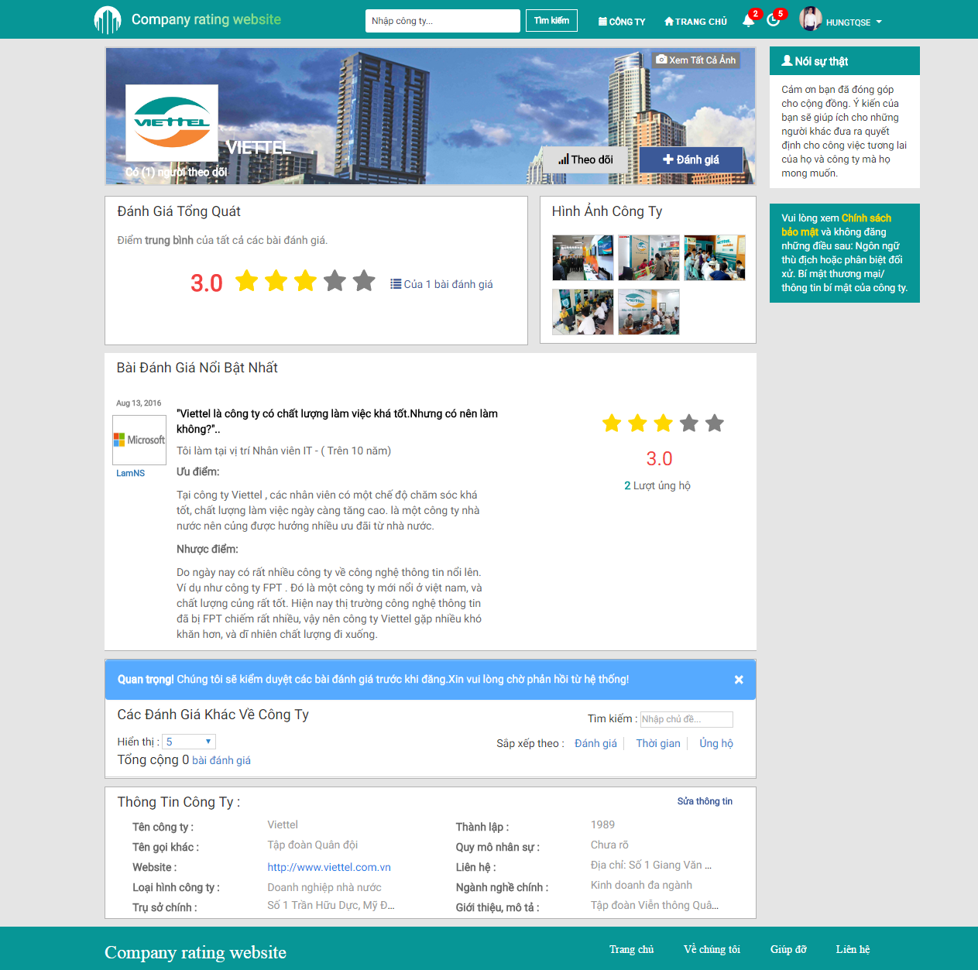

1. Detailed Company Screen

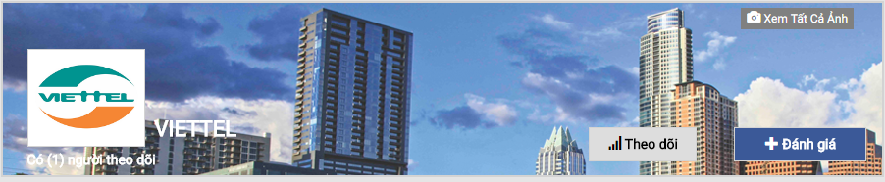

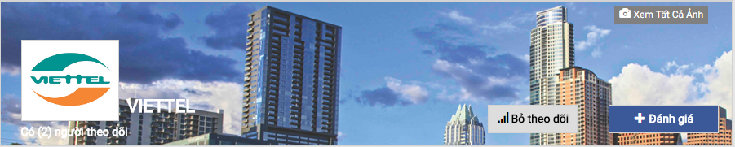

1. Company Banner

| No | Field name | Field name in Vietnamese | Type | Require | Mandatory | Max-Length | Description |
| --- | --- | --- | --- | --- | --- | --- | --- |
|  | Banner | Ảnh banner | Image |  |  |  | Common banner for all companies |
|  | Follow | Theo dõi | Button | Click |  |  | Add the current company to the Follow list |
|  | Unfollow | Bỏ theo dõi | Button | Click |  |  | Remove the current company from the Follow list |
|  | Create Review | Đăng bài | Button | Click |  |  | Go to Create Review screen |
|  | View All Banners | Xem ảnh banner | Button | Click |  |  | Open all banner images in a carousel |
|  | Avatar | Ảnh đại diện | Image |  |  |  | Company’s logo |
|  | Company Name | Tên công ty | Label |  |  |  | Label for company’s name |
|  | Number of followers | Số người theo dõi | Label |  |  |  | Label for showing the amount of followers |

1. Company Banner

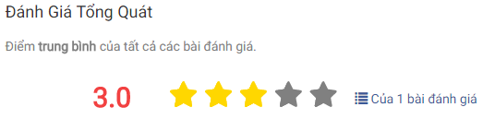

1. Overall Rating

| No | Field name | Field name in Vietnamese | Type | Require | Mandatory | Max-Length | Description |
| --- | --- | --- | --- | --- | --- | --- | --- |
|  | Overall Rating | Điểm đánh giá tổng quát | Label |  |  |  | Label for Overall Rating section |
|  | Average Star Rating | Điểm đánh giá trung bình sao | Star Rating Bar |  |  |  | Show average rating of this company as stars |
|  | Average Rating | Điểm đánh giá trung bình | Label |  |  |  | Show average rating of this company as number |
|  | Detailed Rating | Điểm đánh giá chi tiết | Fade Model | Click |  |  | Show Detailed rating for this Company |

1. Overall Rating

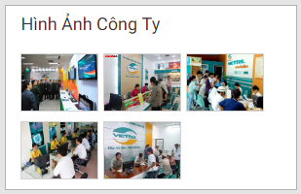

1. Company Photo

| No | Field name | Field name in Vietnamese | Type | Require | Mandatory | Max-Length | Description |
| --- | --- | --- | --- | --- | --- | --- | --- |
|  | Company Photo | Ảnh công ty | Label |  |  |  | Label for Company Photo section |
|  | Company Photo | Ảnh công ty | Image | Hover |  |  | Company’s photo |

1. 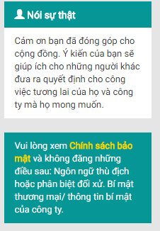Company Photo
2. Note And Policy

| No | Field name | Field name in Vietnamese | Type | Require | Mandatory | Max-Length | Description |
| --- | --- | --- | --- | --- | --- | --- | --- |
|  | Note | Ghi chú | Panel |  |  |  | Show the note regarding review contribution |
|  | Privacy Policy | Chính sách bảo mật | Hyperlink | Click |  |  | Open the Privacy Policy popup modal box |

1. Note And Policy

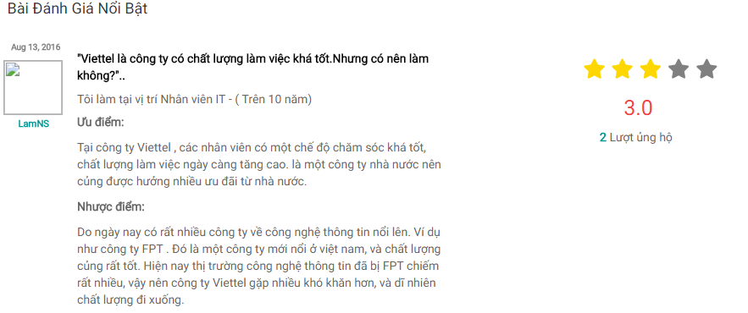

1. Highlighted Review

| No | Field name | Field name in Vietnamese | Type | Require | Mandatory | Max-Length | Description |
| --- | --- | --- | --- | --- | --- | --- | --- |
|  | Highlighted Review | Đánh giá nổi bật | Label |  |  |  | Label for Highlighted Review section |
|  | Highlighted Reviewer Name | Tên người đánh giá nổi bật | Label |  |  |  | Label for the highlighted reviewer’s name |
|  | Highlighted Reviewer Avatar | Ảnh đại diện người đánh giá nổi bật | Image |  |  |  | Highlighted reviewer’s avatar |
|  | Highlighted Review Latest Date | Ngày cập nhật đánh giá nổi bật lần cuối | Label |  |  |  | Label for the highlighted review’s latest updated date |
|  | Highlighted Review Basic Content | Nội dung đánh giá nổi bật căn bản | Panel Body |  |  |  | The basic content of the highlighted review |
|  |  |  |  |  |  |  |  |
|  | Highlighted Review Star Rating | Điểm đánh giá sao | Star Rating Bar |  |  |  | Show the rating given by this highlighted review as stars |
|  | Highlighted Review Rating | Điểm đánh giá nổi bật | Label |  |  |  | Label for the highlighted review’s rating as number |
|  | Highlighted Review Upvote | Số ủng hộ | Label |  |  |  | Label for the highlighted review’s upvote count |
|  | Highlighted Review | Đánh giá nổi bật | Hyperlink | Click |  |  | Go to the Detailed Review screen |

1. Highlighted Review



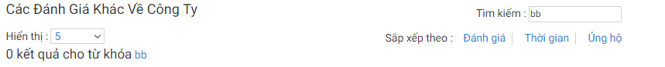

1. Search And Filter (Company Details)

| No | Field name | Field name in Vietnamese | Type | Require | Mandatory | Max-Length | Description |
| --- | --- | --- | --- | --- | --- | --- | --- |
|  | Review | Đánh giá | Label |  |  |  | Label for the Remaining Review section |
|  | Display Limit | Giới hạn hiển thị | Select | Click |  |  | Limit the amount of reviews per single page |
|  | Filter | Bộ lọc | Textbox | Input |  |  | Filter the reviews accordingly to inputted keyword(s) |
|  | Filter Result | Kết quả lọc | Label |  |  |  | Label for amount of matching results with the given keywords |
|  | Sort by Review Rating | Sắp xếp theo điểm đánh giá | Hyperlink | Click |  |  | Sort reviews by ratings numberically |
|  | Sort by Review Date | Sắp xếp thời gian | Hyperlink | Click |  |  | Sort reviews by lastest date |
|  | Sort by Review Upvote | Sắp xếp ủng hộ | Hyperlink | Click |  |  | Sort reviews by upvote count numberically |

1. Search And Filter (Company Details)

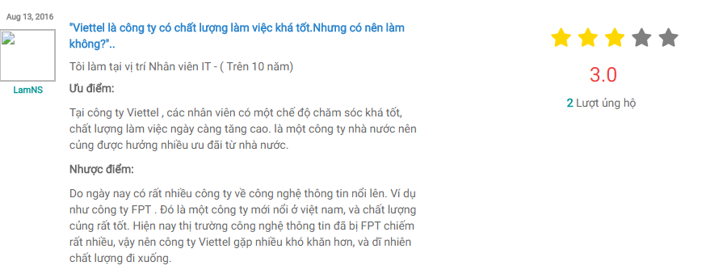

1. Review

| No | Field name | Field name in Vietnamese | Type | Require | Mandatory | Max-Length | Description |
| --- | --- | --- | --- | --- | --- | --- | --- |
|  | Reviewer Name | Tên người đánh giá | Label |  |  |  | Label for the reviewer’s name |
|  | Reviewer Avatar | Ảnh đại diện người đánh giá | Image |  |  |  | Reviewer’s avatar |
|  | Review Latest Date | Ngày cập nhật đánh giá lần cuối | Label |  |  |  | Label for the review’s latest updated date |
|  | Review Basic Content | Nội dung đánh giá căn bản | Panel Body |  |  |  | The basic content of the review |
|  | Review Star Rating | Điểm đánh giá sao | Star Rating Bar |  |  |  | Show the rating given by this review as stars |
|  | Review Rating | Điểm đánh giá | Label |  |  |  | Show the rating given by this review as number |
|  | Review Upvote | Số ủng hộ | Label |  |  |  | Label for the review’s upvote count |
|  | Review | Đánh giá | Hyperlink | Click |  |  | Go to the Detailed Review screen |

1. Review

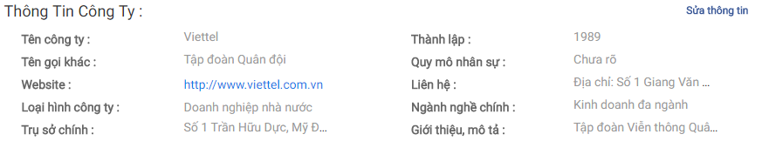

1. Company Info (Company Details)

| No | Field name | Field name in Vietnamese | Type | Require | Mandatory | Max-Length | Description |
| --- | --- | --- | --- | --- | --- | --- | --- |
|  | Company Info | Thông tin công ty | Label |  |  |  | Label for Company Info section |
|  | Company Info | Thông tin công ty | Panel |  |  |  | Show this company’s info |
|  | Company Website | Website công ty | Hyperlink | Click |  |  | Go to this company’s website |
|  | Update Company | Cập nhật công ty | Hyperlink | Click |  |  | Open the Update Company popup modal box (Administrator) |

1. Company Info (Company Details)

## Update Company

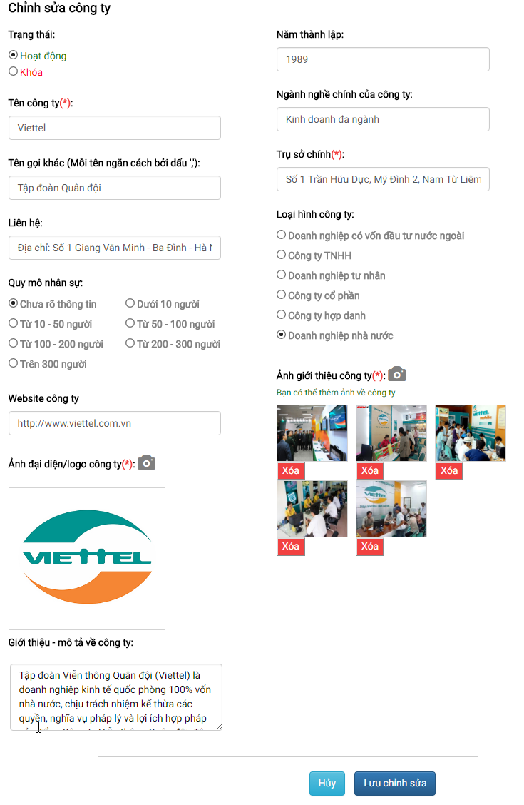

1. Update Company Modal Box

| No | Field name | Field name in Vietnamese | Type | Require | Mandatory | Max-Length | Description |
| --- | --- | --- | --- | --- | --- | --- | --- |
|  | Update Company | Chỉnh sửa công ty | Label |  |  |  | Label for Update Company modal box |
|  | Company Status | Trạng thái công ty | Radio Button | Click | Y |  | Current and avaiable states of this company |
|  | Company Name | Tên công ty | Textbox | Input | Y |  | Input company’s name |
|  | Company Name | Tên công ty | Label |  |  |  | Label for Company Name when field is empty or does not meet requirement |
|  | Company Alias | Tên gọi khác | Textbox | Input |  |  | Input company’s alias name |
|  | Company Contact | Liên hệ | Textbox | Input |  |  | Input company’s contact |
|  | Company Personnel Size | Quy mô nhân sự | Radio Button | Click |  |  | Choose the range of this company’s personnel size |
|  | Company Website | Trang web của công ty | Textbox |  |  |  | Input company’s website |
|  | Company Avatar Upload | Đăng ảnh đại diện | Button | Click |  |  | Open the Explorer to choose an image as this company’s logo |
|  | Company Avatar | Ảnh đại diện | Image |  | Y |  | Image previewer for company’s uploaded logo |
|  | Company Avatar | Ảnh đại diện | Label |  |  |  | Label for Company Avatar when field is empty or does not meet requirement |
|  | Company Avatar Accept | Chấp nhận ảnh đại diện | Button | Click |  |  | Accept the currently uploaded image as this company’s logo |
|  | Company Avatar Reject | Bỏ ảnh đại diện | Button | Click |  |  | Reject the currently uploaded image as this company’s logo |
|  | Company Introduction | Giới thiệu về công ty | Textarea | Input |  |  | Input summary of this company |
|  | Company Founded Date | Năm thành lập | Date Picker | Click |  |  | Choose the founded year of this company |
|  | Company Industrial Focus | Ngành nghề chính công ty | Textbox |  |  |  | Input the company’s industrial focus |
|  | Company HQ | Trụ sở chính | Textbox | Input | Y |  | Input the company’s headquarter |
|  | Company HQ | Trụ sở chính | Label |  |  |  | Label for Company HQ when field is empty or does not meet requirement |
|  | Company Type | Loại hình công ty | Radio Button | Click |  |  | Choose a type for this company’s type |
|  | Company Photo Upload | Đăng ảnh công ty | Button | Click |  |  | Open the Explorer to choose an image as this company’s photo |
|  | Company Photo | Ảnh công ty | Image |  | Y |  | Image previewer for company’s uploaded photo |
|  | Company Photo | Ảnh công ty | Label |  |  |  | Label for Company Photo when field is empty or does not meet requirement |
|  | Company Photo Accept | Chấp nhận ảnh công ty | Button | Click |  |  | Accept the currently uploaded image as this company’s photo |
|  | Company Photo Reject | Bỏ ảnh công ty | Button | Click |  |  | Reject the currently uploaded image as this company’s photo |
|  | Company Photo Remove | Xóa ảnh công ty | Button | Click |  |  | Remove a company photo |

1. Update Company Modal Box

## Create Review

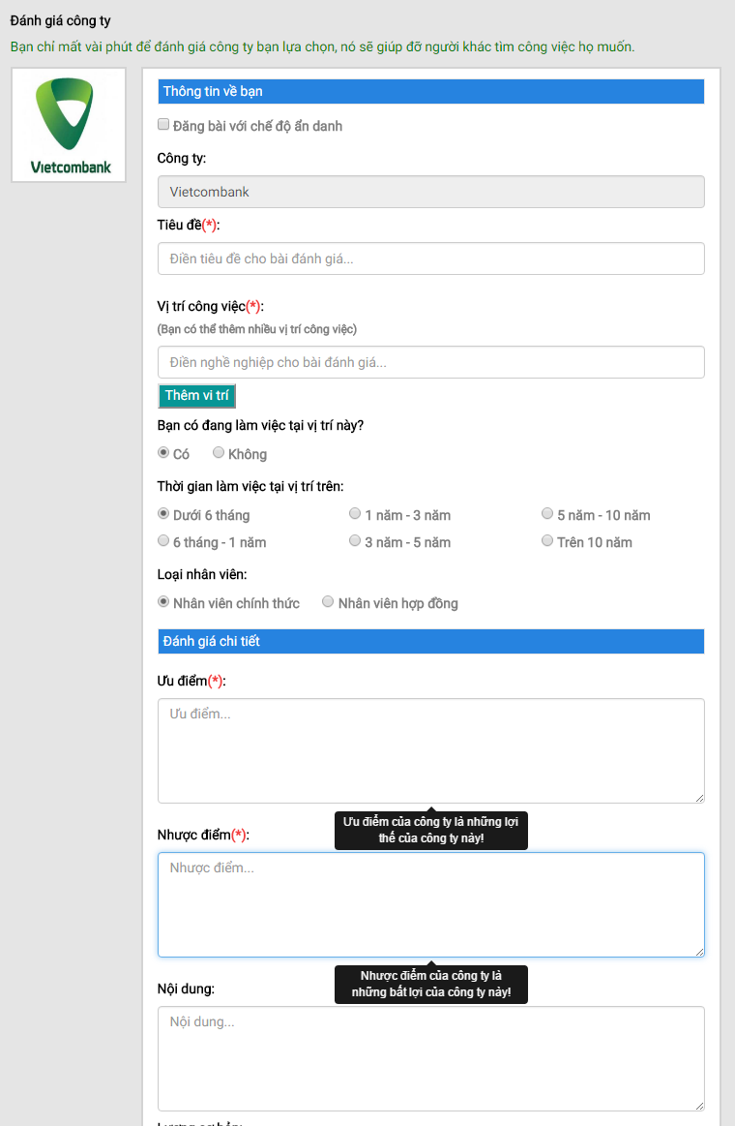

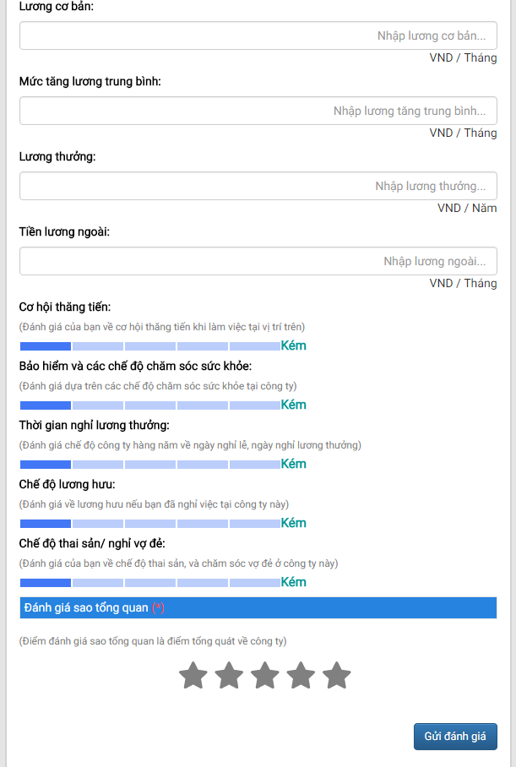

1. Create Review Screen

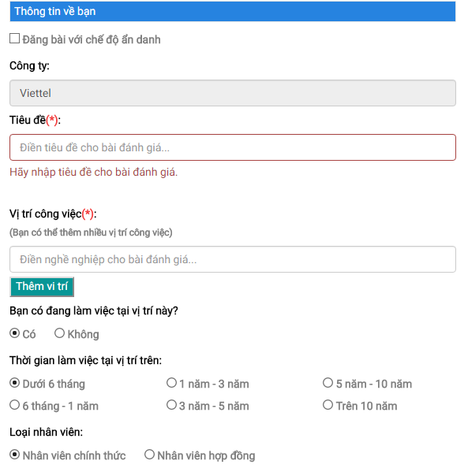

1. Reviewer Info

| No | Field name | Field name in Vietnamese | Type | Require | Mandatory | Max-Length | Description |
| --- | --- | --- | --- | --- | --- | --- | --- |
|  | Reviewer Info | Thông tin về người đánh giá | Label |  |  |  | Label for Reviewer Info section |
|  | Anonymity | Ẩn danh | Checkbox | Click |  |  | Enable anonymity mode for posting review |
|  | Company Name | Tên công ty | Textbox |  | Y |  | Automatically inputted company’s name |
|  | Review Title | Tiêu đề đánh giá | Textbox | Input | Y |  | Input review’s title |
|  | Review Title | Tiêu đề đánh giá | Label |  |  |  | Label for Review Title when field is empty or does not meet requirement |
|  | Profession | Nghề nghiệp | Auto Complete Textbox | Input | Y |  | Input or choose from a pre-existing profession in the system |
|  | Profession | Nghề nghiệp | Button | Click |  |  | Add the inputted profession as the reviewer’s |
|  | Current Profession | Nghề nghiệp hiện tại | Radio button | Click |  |  | Define whether the reviewer is currently working as the chosen profession |
|  | Profession Length | Thời gian làm việc | Radio button | Click |  |  | Define the amount of time spent as the chosen profession |
|  | Profession Contract | Hợp đồng | Radio button | Click |  |  | Define the type of contract for the chosen profession |

1. Reviewer Info

**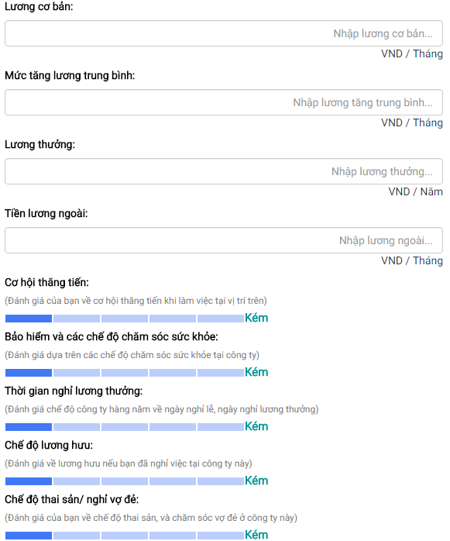**

**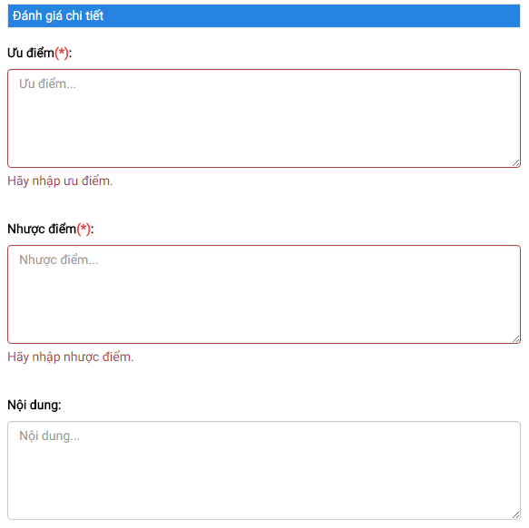**

1. Review Details

| No | Field name | Field name in Vietnamese | Type | Require | Mandatory | Max-Length | Description |
| --- | --- | --- | --- | --- | --- | --- | --- |
|  | Review Details | Đánh giá chi tiết | Label |  |  |  | Label for Review Details section |
|  | Pros | Ưu điểm | Textarea | Input | Y |  | Input the pros of working as the chosen profession in this company |
|  | Pros | Ưu điểm | Label |  |  |  | Label for Pros when field is empty or does not meet requirement |
|  | Cons | Nhược điểm | Textarea | Input | Y |  | Input the cons of working as the chosen profession in this company |
|  | Cons | Nhược điểm | Label |  |  |  | Label for Cons when field is empty or does not meet requirement |
|  | Content | Nội dung | Textarea | Input |  |  | Input additional information as needed regarding the company |
|  | Base Pay | Lương cơ bản | Textbox | Input |  |  | Input basic payment when reviewer first started as the chosen profession |
|  | Pay Raise | Lương tăng trưởng trung bình | Textbox | Input |  |  | Input payment raise as reviewer continously work as the chosen profession |
|  | Bonus Pay | Lương thưởng | Textbox | Input |  |  | Input bonus payment as reviewer excels at his chosen profession |
|  | Other Pay | Tiền lương ngoài | Textbox | Input |  |  | Input outside payment as reviewer continously work as the chosen profession |
|  | Currency | Đơn vị tiền tệ | Label |  |  |  | Label for depicting the currency of payments |
|  | Promotion Opportunity | Cơ hội thăng tiến | Select | Click |  |  | Grade the chances of getting a promotion |
|  | Healthcare | Chăm sóc sức khỏe | Select | Click |  |  | Grade the healthcare provided by this company |
|  | Paid Leave | Nghỉ hưởng lương | Select | Click |  |  | Grade the paid leave provided by this company |
|  | Pension | Lương hưu | Select | Click |  |  | Grade the pension provided by this company |
|  | Parental Leave | Thai sản | Select | Click |  |  | Grade the parental leave by this company |
|  | Explanation | Giải thích | Label |  |  |  | Label for explaining which field does what |

1. Review Details

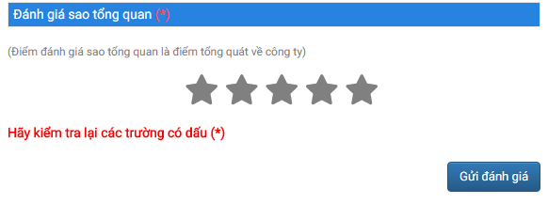

1. Review Rating

| No | Field name | Field name in Vietnamese | Type | Require | Mandatory | Max-Length | Description |
| --- | --- | --- | --- | --- | --- | --- | --- |
|  | Review Rating | Điểm đánh giá | Label |  |  |  | Label for Review Rating section |
|  | Total Rating | Điểm đánh giá tổng | Select | Click | Y |  | Grade the company |
|  | Mandatory | Yêu cầu | Label |  |  |  | Label for all mandatory fields when they are empty or do not meet requirement |
|  | Submit Review | Gửi đánh giá | Button | Click |  |  | Submit the review for approval |

1. Review Rating

## Review Details

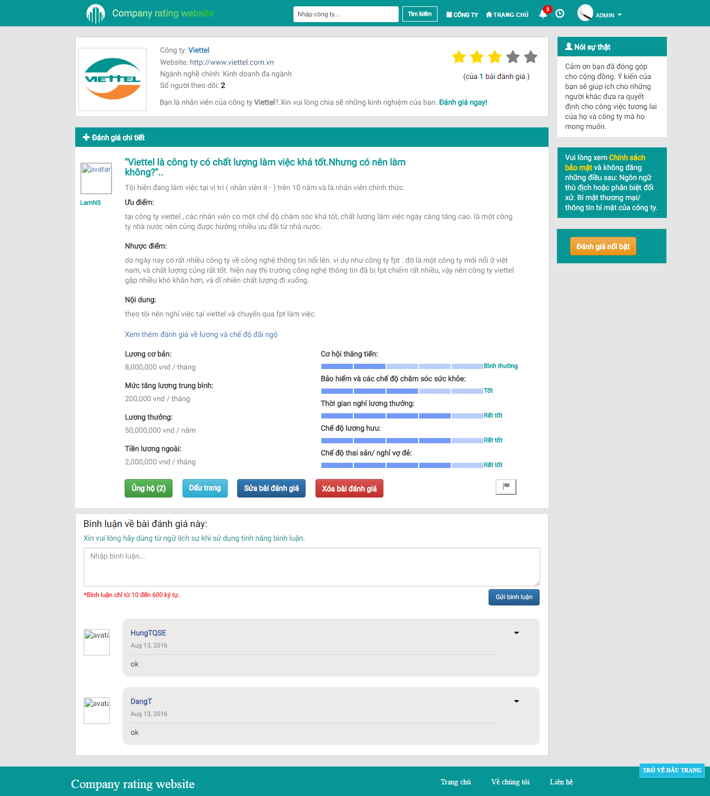

1. Detailed Review Screen

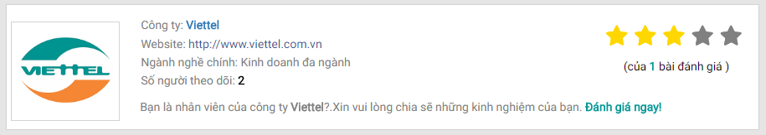

1. Company Info (Review Details)

| No | Field name | Field name in Vietnamese | Type | Require | Mandatory | Max-Length | Description |
| --- | --- | --- | --- | --- | --- | --- | --- |
|  | Avatar | Ảnh đại diện | Image |  |  |  | Company’s logo |
|  | Company Name | Tên công ty | Hyperlink |  |  |  | Go to this company’s Detailed Company screen |
|  | Company Website | Website công ty | Hyperlink | Click |  |  | Go to this company’s website |
|  | Number of Followers | Số người theo dõi | Label |  |  |  | Label for showing the amount of followers |
|  | Average Star Rating | Điểm đánh giá trung bình | Star Rating Bar |  |  |  | Show average ratings of this company as stars |
|  | Number of Reviewers | Số người đánh giá | Label |  |  |  | Label for showing the amount of reviewers |
|  | Create Review | Đăng bài | Hyperlink | Click |  |  | Go to Create Review screen |

1. Company Info (Review Details)

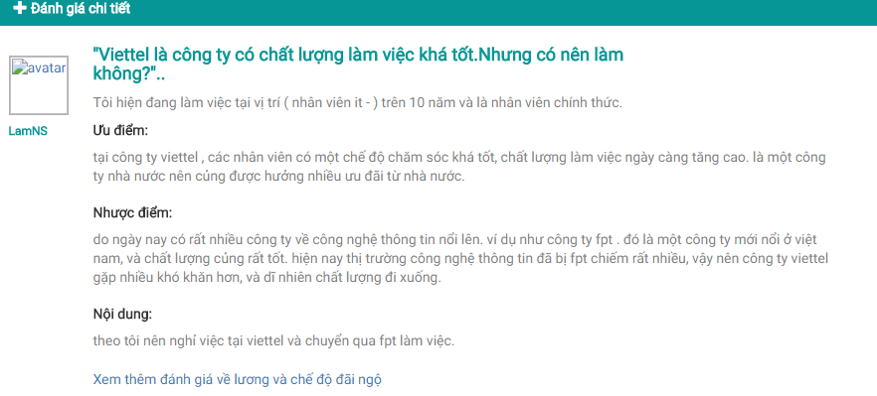

1. Review Basic Content

| No | Field name | Field name in Vietnamese | Type | Require | Mandatory | Max-Length | Description |
| --- | --- | --- | --- | --- | --- | --- | --- |
|  | Review Details | Chi tiết đánh giá | Label |  |  |  | Label for the review section |
|  | Reviewer | Người đánh giá | Hyperlink | Click |  |  | Go to the reviewer’s Account Info Screen |
|  | Reviewer Name | Tên người đánh giá | Label |  |  |  | Label for the reviewer’s name |
|  | Reviewer Avatar | Ảnh đại diện người đánh giá | Image |  |  |  | Reviewer’s avatar |
|  | Review Basic Content | Nội dung đánh giá căn bản | Panel Body |  |  |  | The basic content of the review |
|  | Review Salary And Benefit | Đánh giá lương và đãi ngộ | Hyperlink | Click |  |  | Display the Salary and Benefit section of the review |

1. Review Basic Content

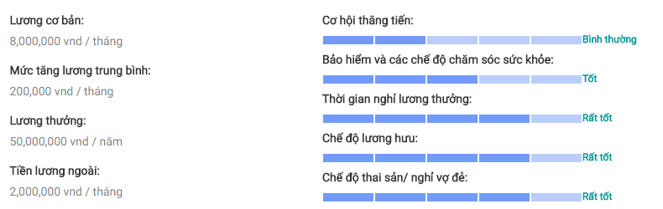

1. Review Salary And Benefits

| No | Field name | Field name in Vietnamese | Type | Require | Mandatory | Max-Length | Description |
| --- | --- | --- | --- | --- | --- | --- | --- |
|  | Review Salary | Đánh giá lương | Panel Body |  |  |  | The Salary section of the review |
|  | Review Benefit | Đánh giá đãi ngộ | Disabled Select |  |  |  | The Benefit section of the review |

1. Review Salary And Benefits

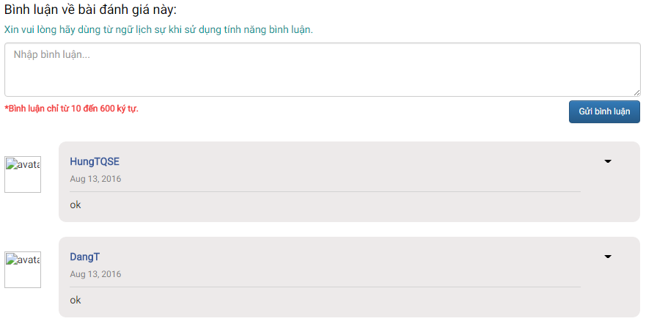

1. Comment

| No | Field name | Field name in Vietnamese | Type | Require | Mandatory | Max-Length | Description |
| --- | --- | --- | --- | --- | --- | --- | --- |
|  | Comment | Bình luận | Label |  |  |  | Label for Comment section |
|  | Comment Note | Chú ý bình luận | Label |  |  |  | Label for noting the rules regarding comment |
|  | Comment Content | Nội dung bình luận | Textarea | Input |  | 10 -600 | Input comment regarding this review |
|  | Comment Limit | Giới hạn bình luận | Label |  |  |  | Label for noting the limit regarding comment length |
|  | Submit Comment | Gửi bình luận | Button | Click |  |  | Submit the inputted comment |
|  | Commenter Avatar | Ảnh đại diện người bình luận | Image |  |  |  | Commenter’s avatar |
|  | Commenter Name | Tên người bình luận | Label |  |  |  | Name of the commenter |
|  | Comment Date | Ngày gửi bình luận | Label |  |  |  | Show when the comment was submitted |
|  | Commentary | Bình luận về đánh giá | Text |  |  |  | The content of a comment regarding this review |
|  | Comment Delete | Xóa comment | Button | Click |  |  | Delete the chosen comment (Comment Owner, Administrator) |

1. Comment

E:\SHAREXXX\Screenshots\2016-08\opera_2016-08-18_20-12-23.png

E:\SHAREXXX\Screenshots\2016-08\opera_2016-08-18_20-12-40.png

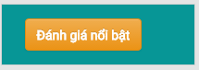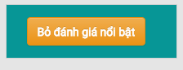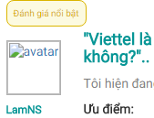

1. Other Functions (Review Details)

| No | Field name | Field name in Vietnamese | Type | Require | Mandatory | Max-Length | Description |
| --- | --- | --- | --- | --- | --- | --- | --- |
|  | Upvote | Ủng hộ | Button | Click |  |  | Give an upvote to the current review |
|  | Remove Upvote | Bỏ ủng hộ | Button | Click |  |  | Remove the given upvote from the current review |
|  | Bookmark | Dấu trang | Button | Click |  |  | Add the current review to the Bookmark list |
|  | Remove Bookmark | Bỏ dấu trang | Button | Click |  |  | Remove the current review from the Bookmark list |
|  | Edit Review | Sửa bài đánh giá | Button | Click |  |  | Go to the Update Review screen (Review Owner, Administrator) |
|  | Remove Review | Xóa bài đánh giá | Button | Click |  |  | Open the Remove Confirmation popup modal box (Review Owner, Administrator) |
|  | Report Review | Báo cáo bài đánh giá | Button | Click |  |  | Open the Report Reasoning popup modal box |
|  | Highlight Status | Trạng thái nổi bật | Label |  |  |  | Show the highlight status of the current review |
|  | Highlight | Nổi bật | Button | Click |  |  | Give the current review a highlight status (Administrator) |
|  | Remove Highlight | Bỏ nổi bật | Button | Click |  |  | Remove the current review’s highlight status (Administrator) |

1. Other Functions (Review Details)

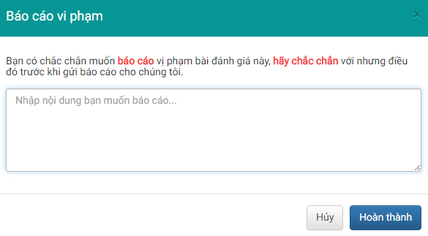

1. Report Reasoning Modal Box

| No | Field name | Field name in Vietnamese | Type | Require | Mandatory | Max-Length | Description |
| --- | --- | --- | --- | --- | --- | --- | --- |
|  | Report | Báo cáo | Label |  |  |  | Label for Report Reasoning modal box |
|  | Report Note | Chú ý báo cáo | Label |  |  |  | Label for noting the reporter on the rules |
|  | Report Content | Nội dung báo cáo | Textarea | Input |  |  | Input report’s reasoning |
|  | Submit Report | Gửi báo cáo | Button | Click |  |  | Submit the report |
|  | Cancel Report | Hủy | Button | Click |  |  | Cancel the report |

1. Report Reasoning Modal Box